Datawarehouse Modelling:

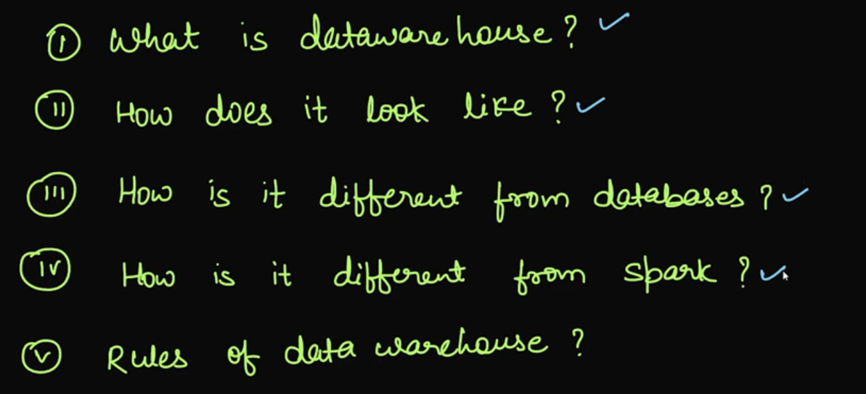

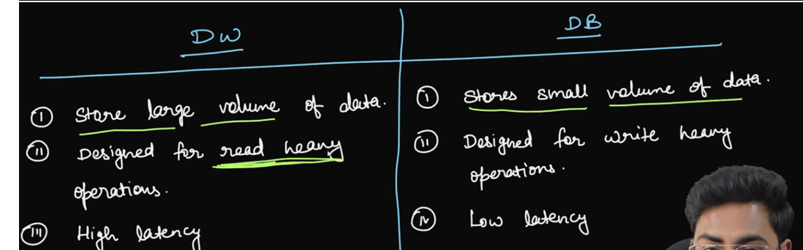



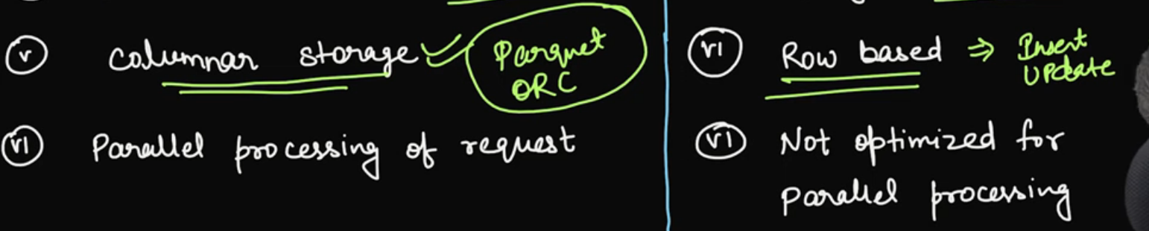

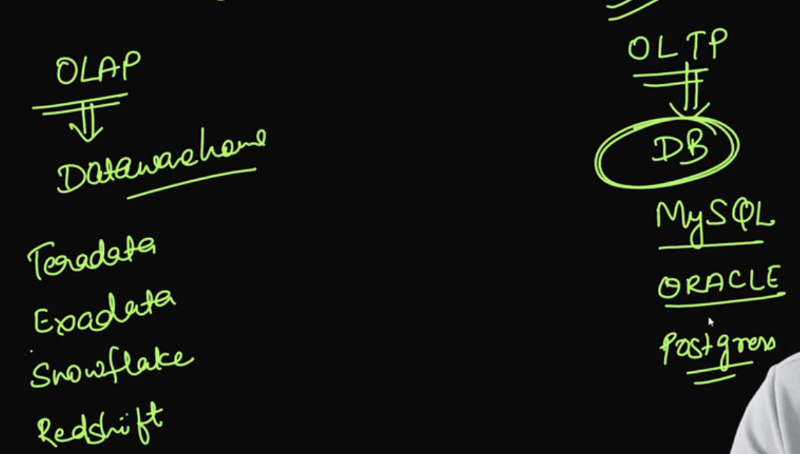

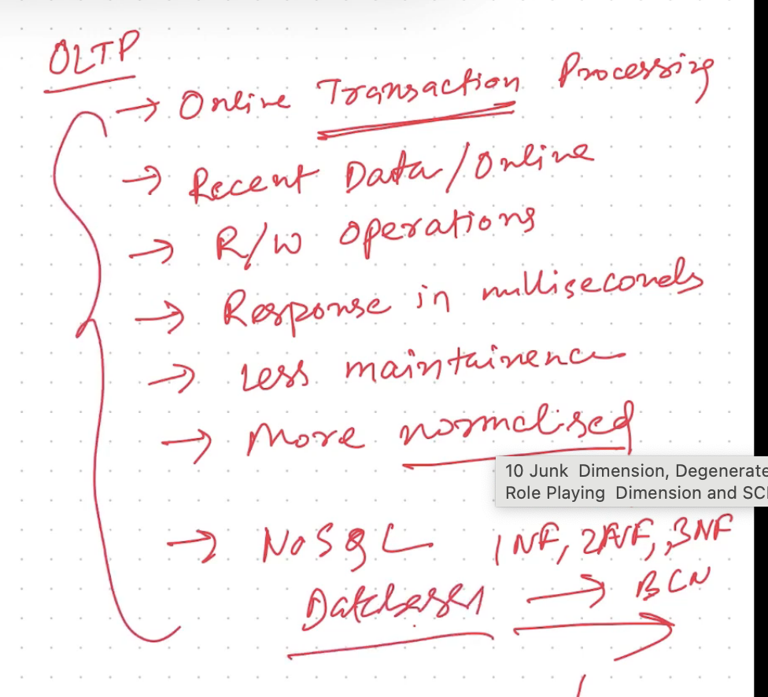

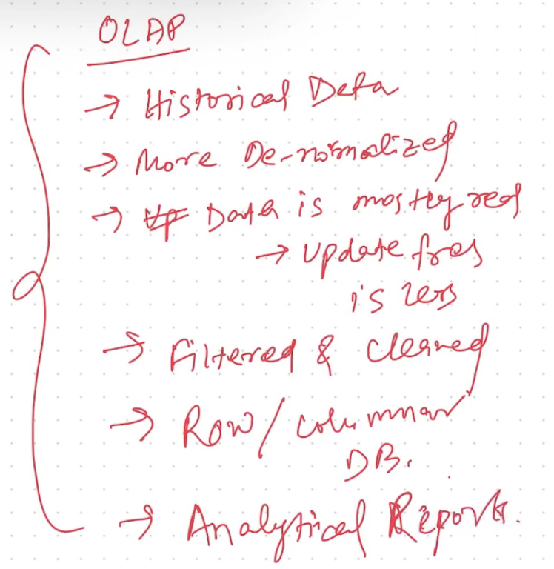

How Datawarehouse different from Spark:

* Datawarehouse doesn’t provide AI/ML and streaming capability
* Spark runs on low commodity machines, whereas Datawarehouse runs on high commodity machines
* Spark can process structured, unstructured and semi-structured data, whereas datawarehouse process mostly structured data

Rules of Datawarehouse:

* Integration: In DW data is copied from multiple sources and it is integrated

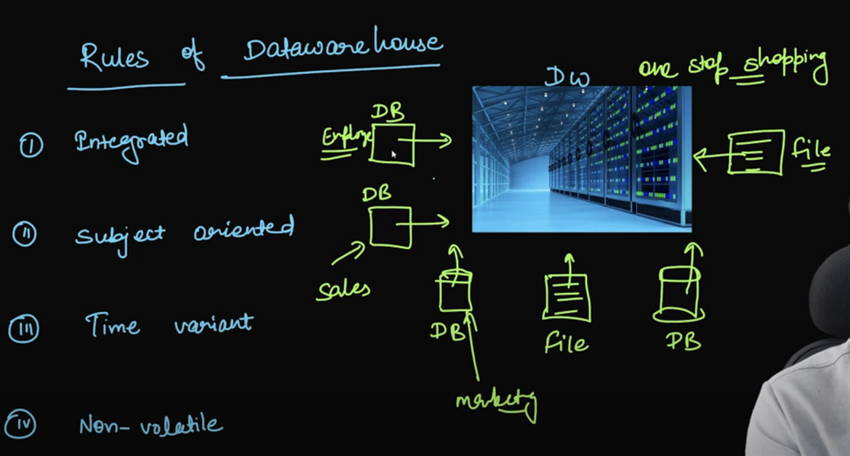

* Subject Oriented: DW is built of specific purpose, like sales analysis, cost analysis
* Timevariant: It represents historical data, like we need to decide how much historical data can be stored
* Non-valitile: Data results won’t be changed over a period

Issues without DW:

* Performance of DB goes down as we will run lot of quiries on DB itself
* We can’t keep lot of historical data on DB
* Data has to be fetched from multiple places which is a complex task

Advantages of DW:

* 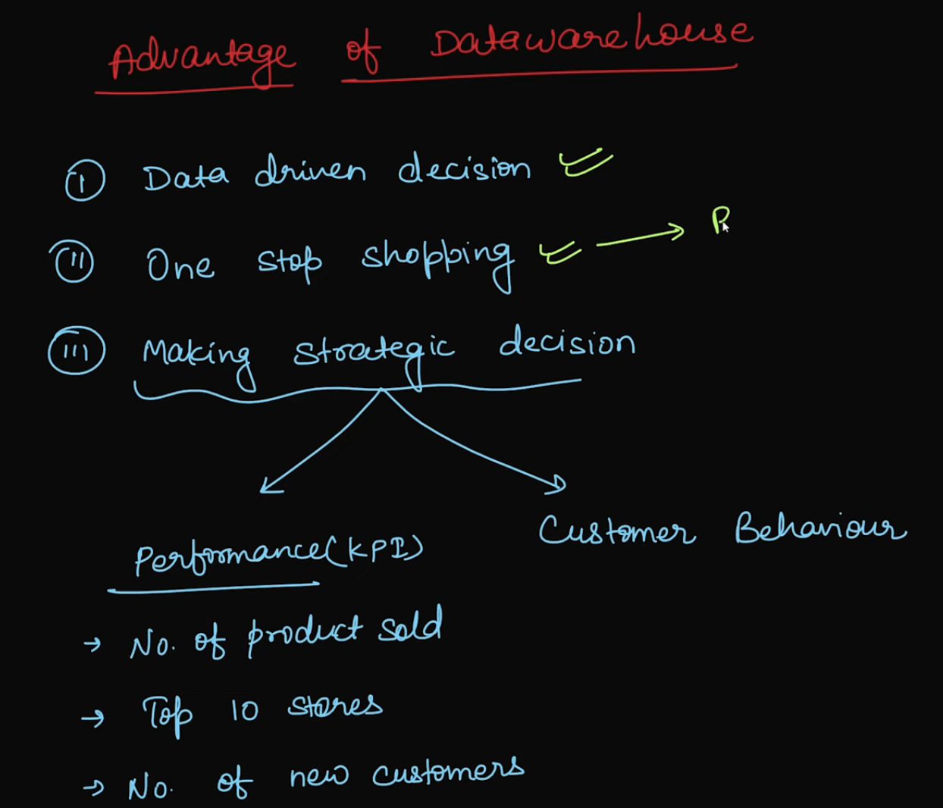

Datawarehouse Flow:

* 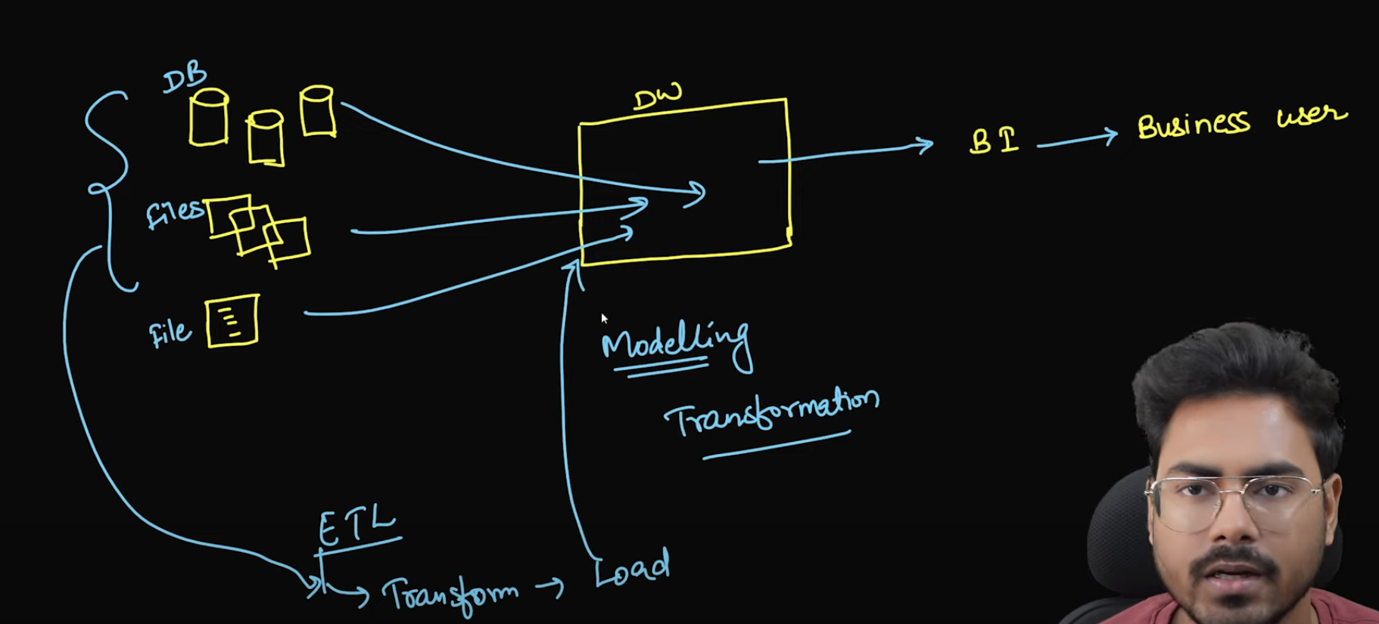

DataLake:

* Problem with DW is modelling is done at first
* DW supports only structured and semi-structured data

Datalake Flow Initial Archirecture:

* 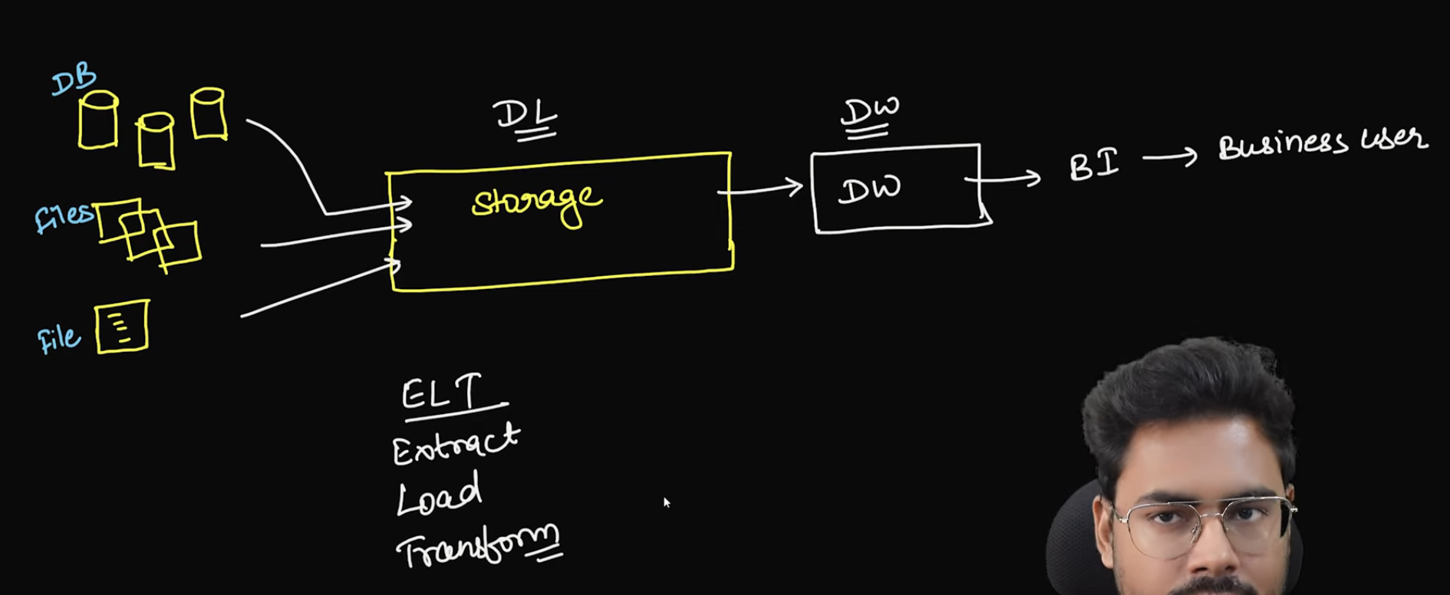

DL Medallion Architecture:

* 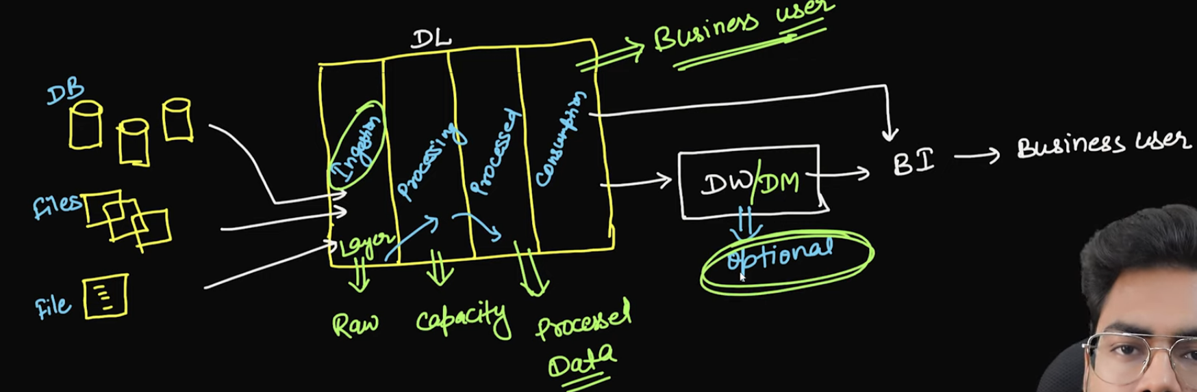

DW vs DL:

* 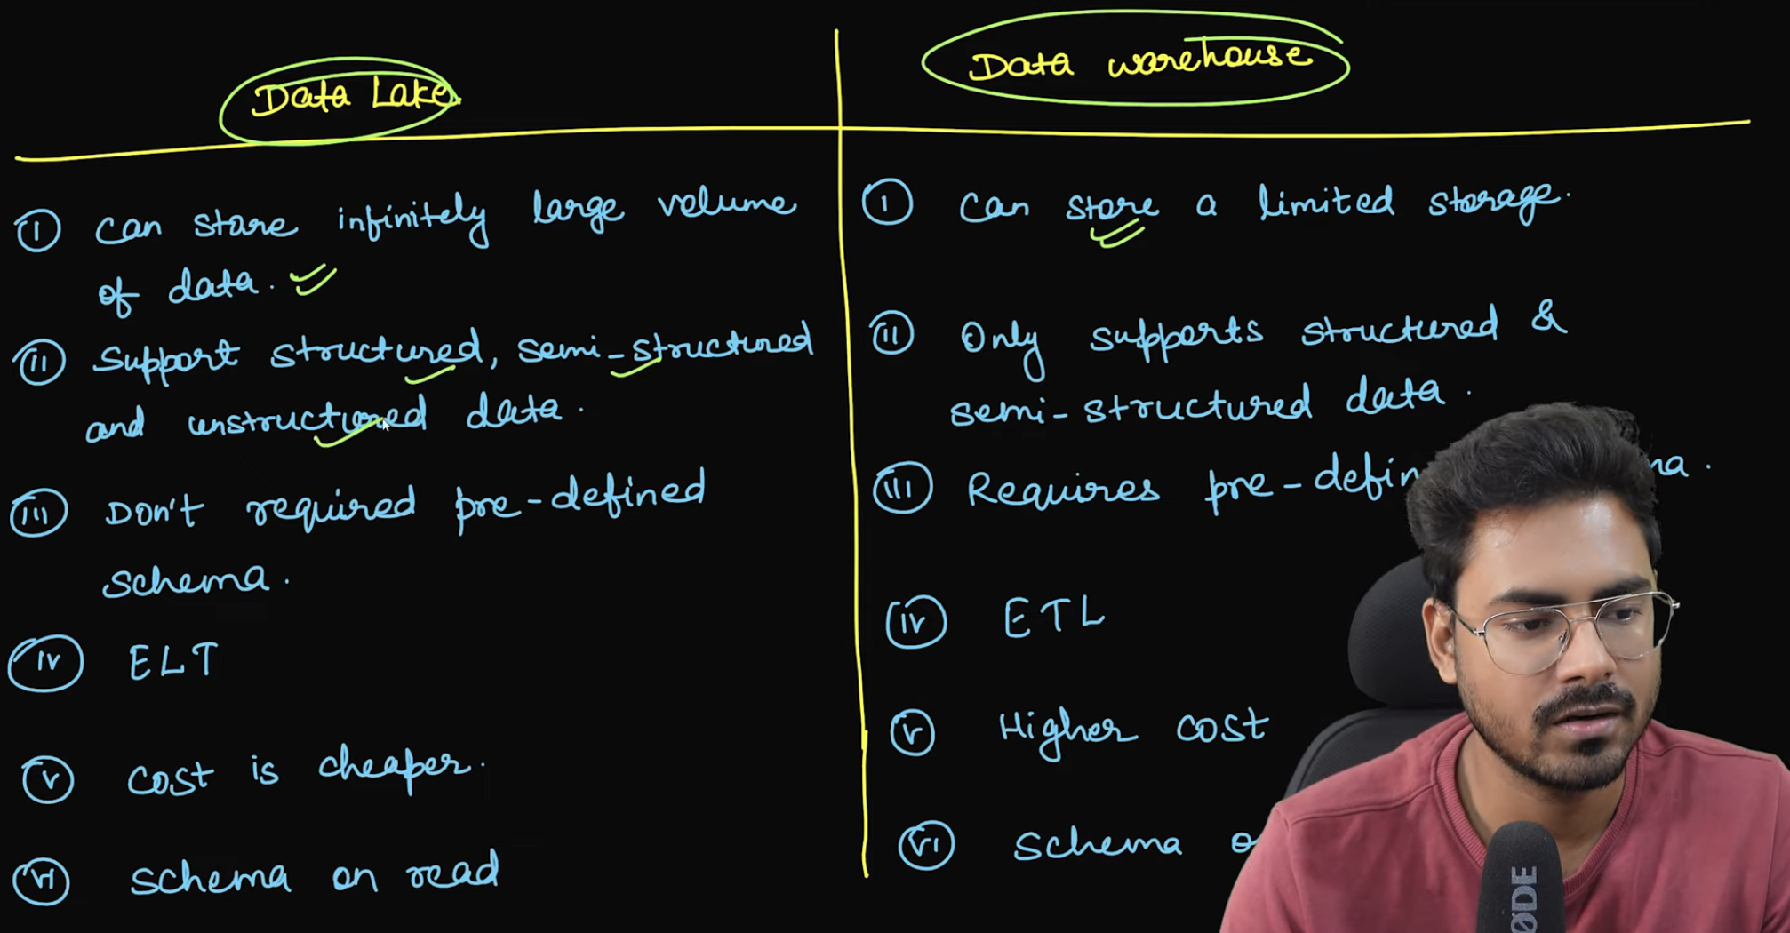
* Data Mart:
* A **Data Mart** is a subset of a **Data Warehouse** that is focused on a specific business area or department within an organization. It contains a smaller, more focused collection of data that is tailored to the needs of a particular group of users, such as marketing, sales, finance, or customer service.
* Data Mart is subject oriented like HR, Retail
* 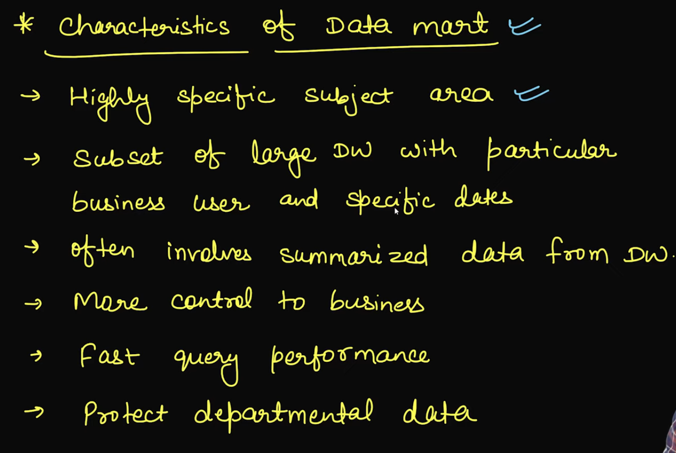
* Analogy
* 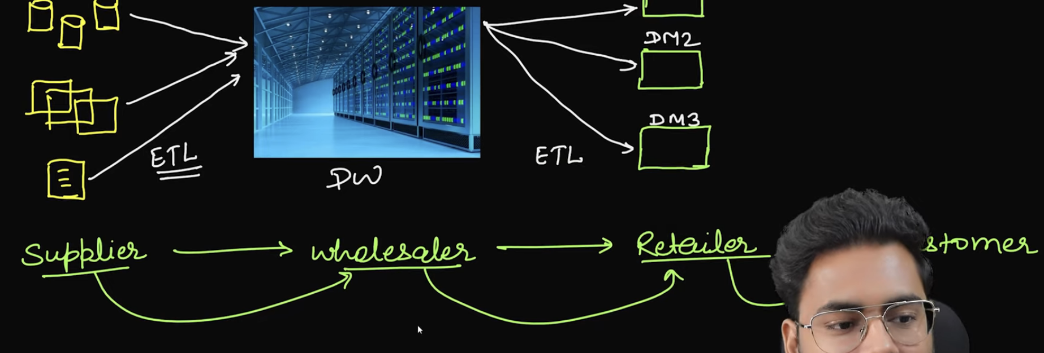
* Dependent Data Mart:
* 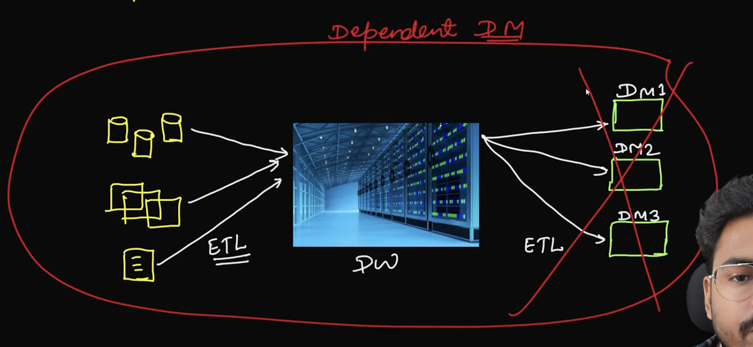

If DW doesn’t exists then DM also doesn’t exists

Independent Data Mart

* 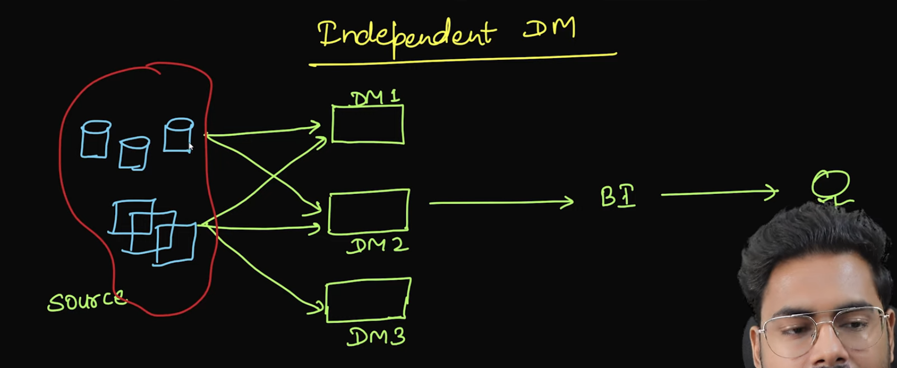
* 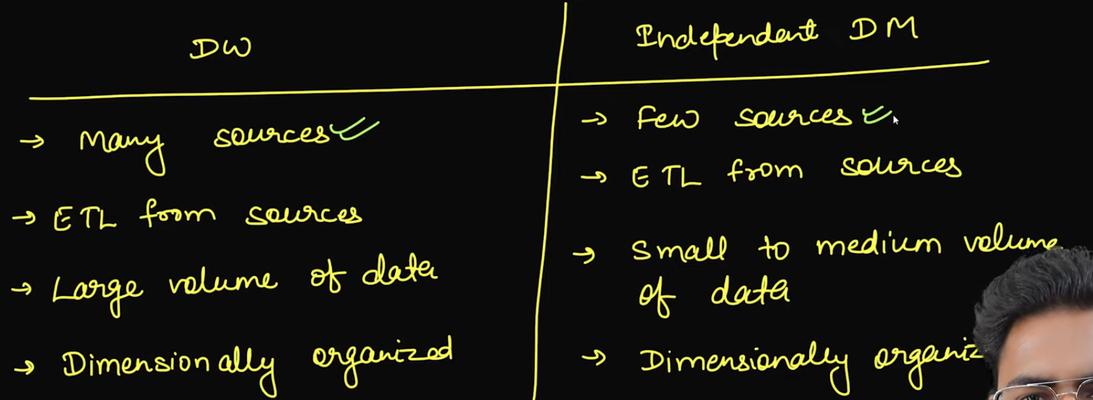

DW Internals:

* 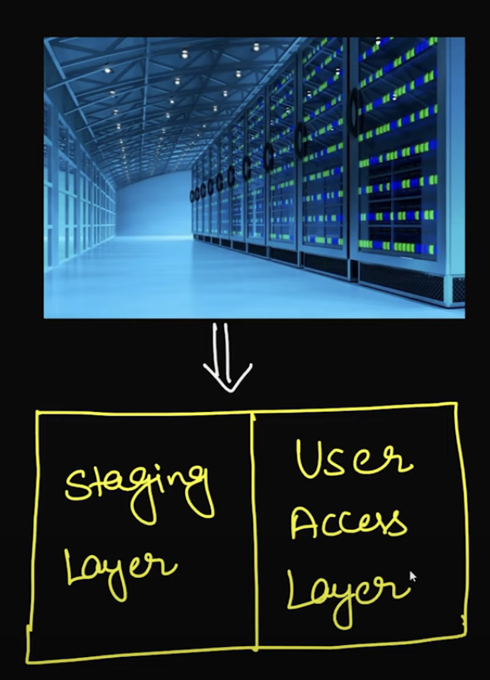

Landing zone is the place where data from multiple sources will come as is.

* 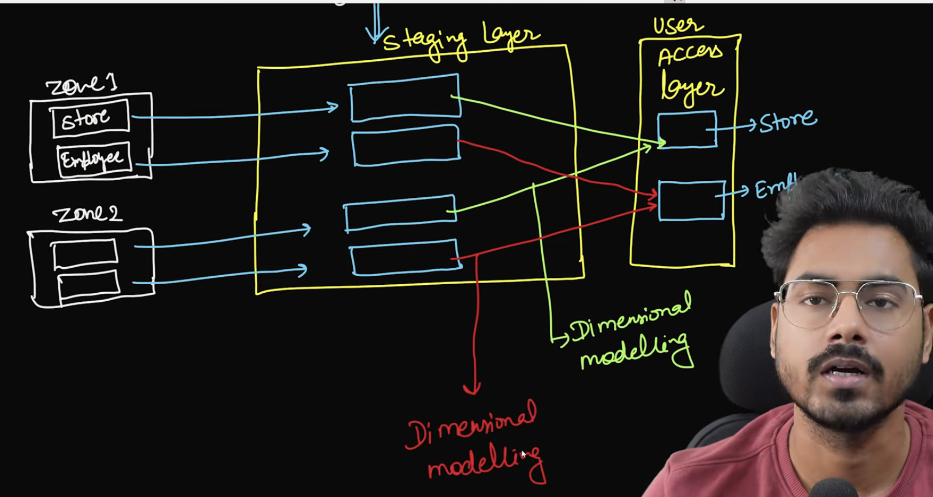

In staging area we get data from multiple zones and later we do dimensional modelling and user access layer will have consolidated data of all zones

* 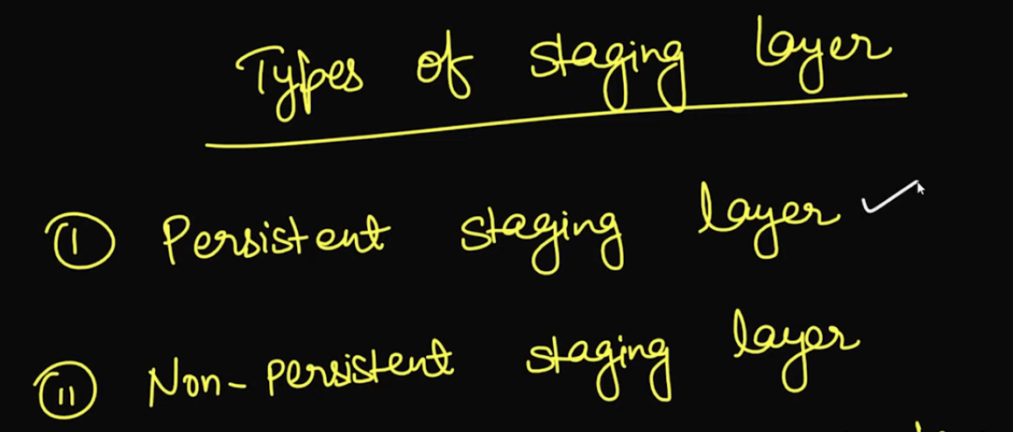

After extract and load if we discard source data then we call it non-persistent layer

* 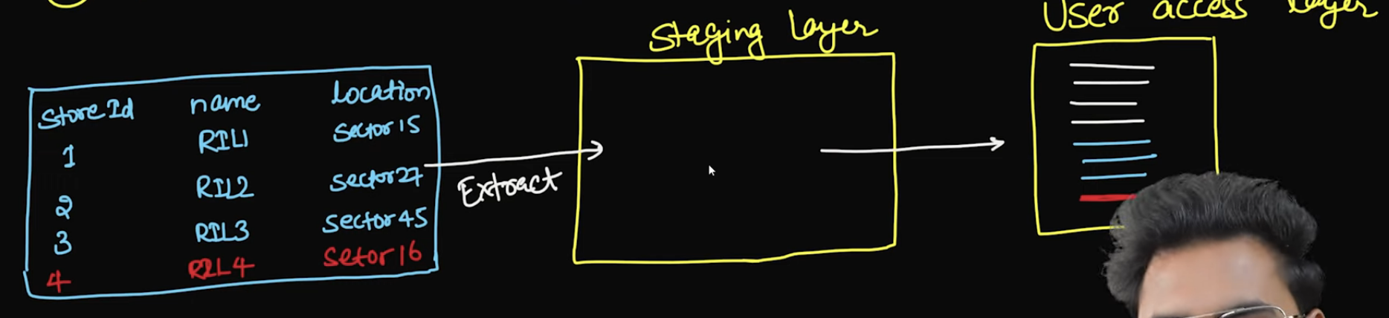
* 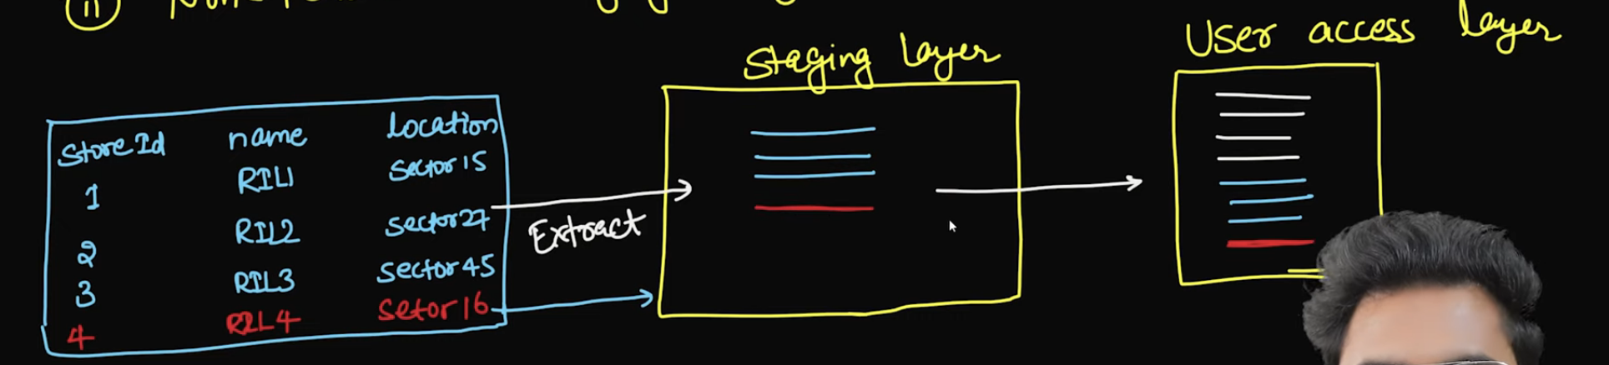
* 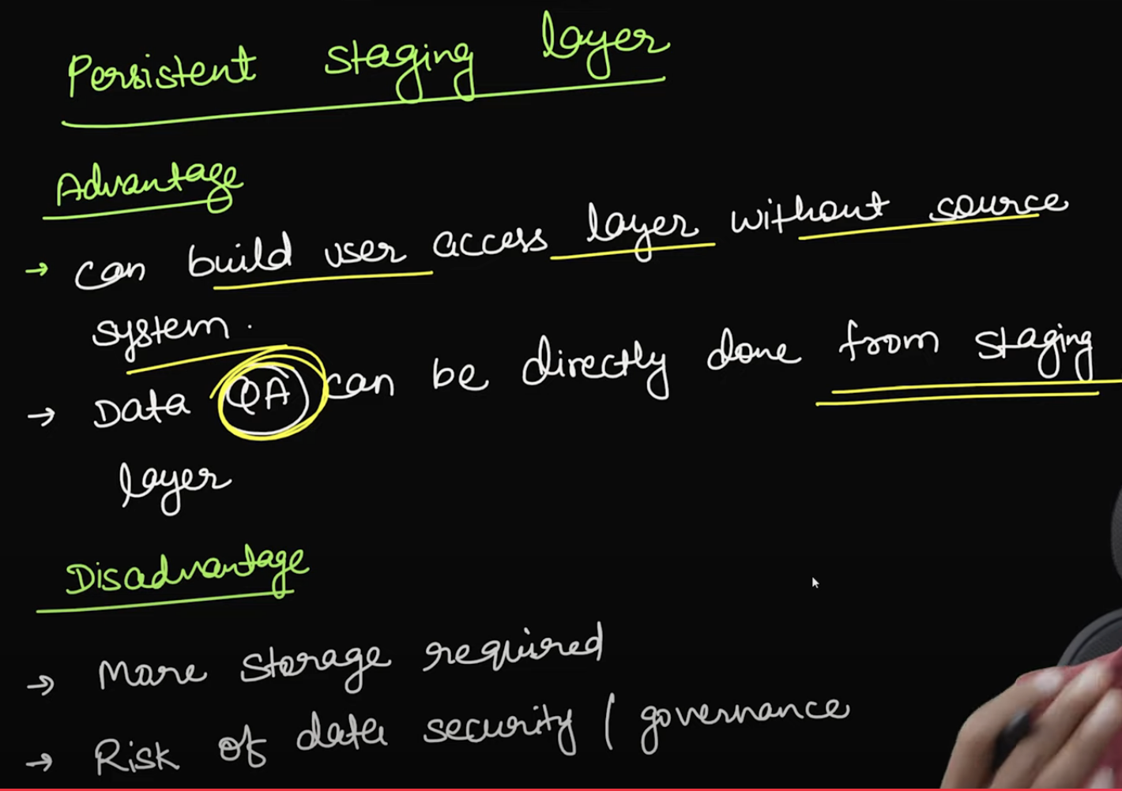
* 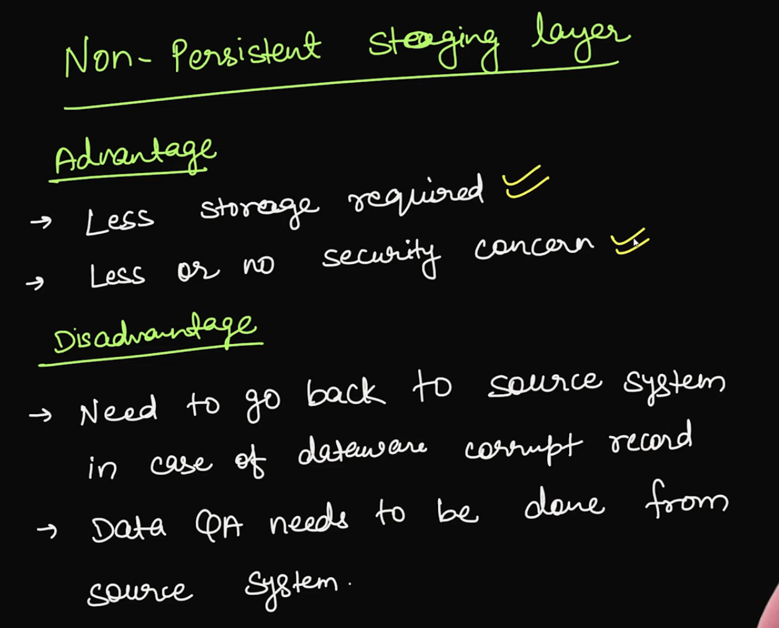

Transformations:

* Uniformity
* restricting

In transformation we mainly look into uniformity and restricting

Suppose zone-1 has 30 columns and zone-2 has 35 columns, we restructure so that resultant data will have same columns

Common Transformations:

Zone 1 has column with Y/N where as zone-2 has column with active column, we standardize it

* 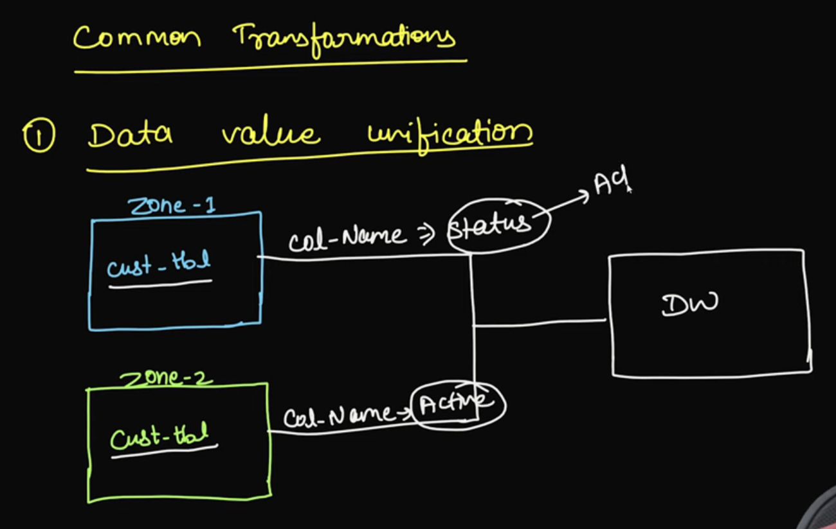
* 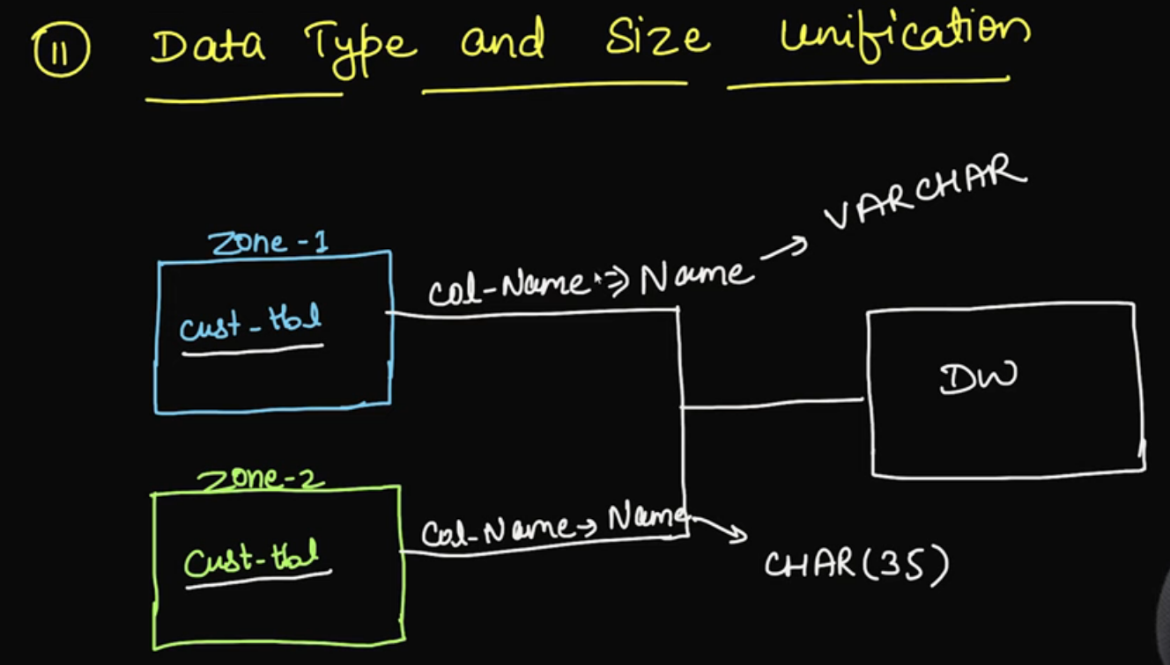

**Deduplication** in the context of a **data warehouse** refers to the process of identifying and removing **duplicate records** or data entries to ensure that only unique, accurate, and necessary data is stored and processed in the data warehouse. This is crucial for maintaining high-quality data and for ensuring that analytics, reporting, and business intelligence (BI) are based on accurate and non-redundant data.

* 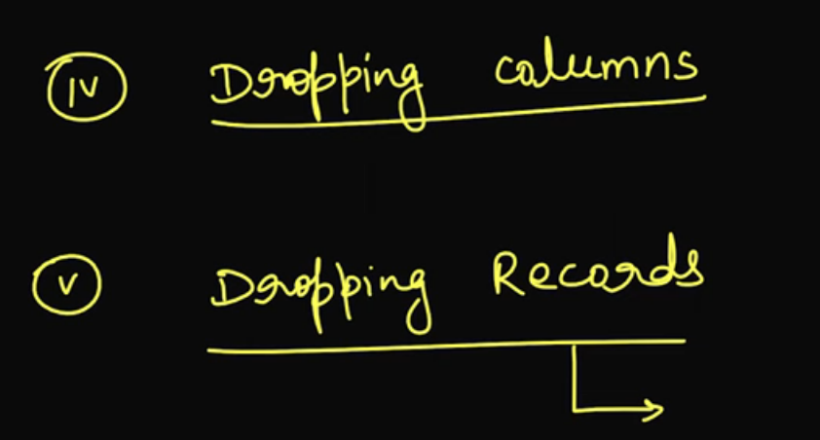
* 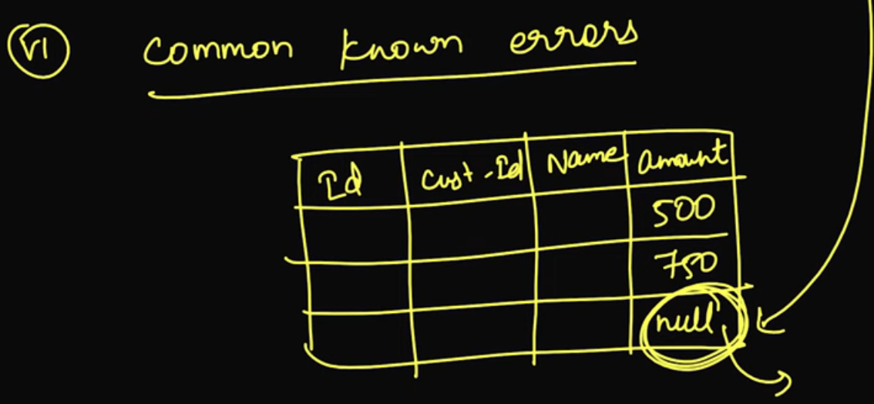

Load:

* 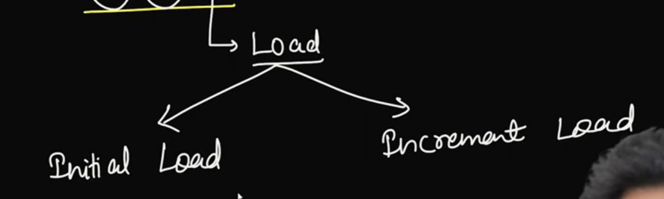
* 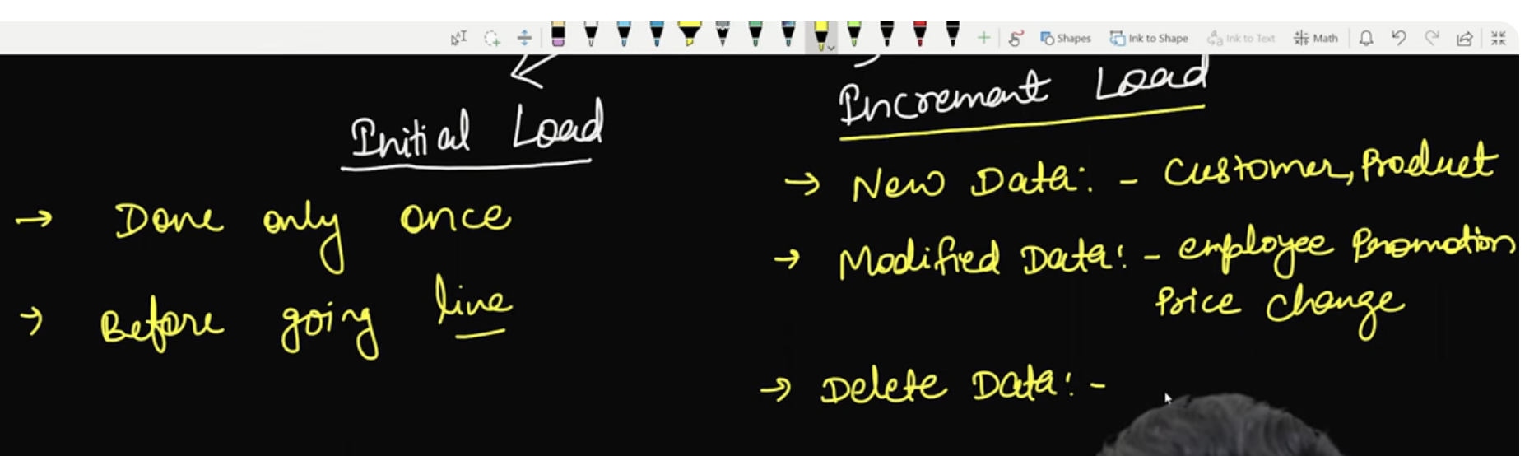

Types of Incremental Load

* 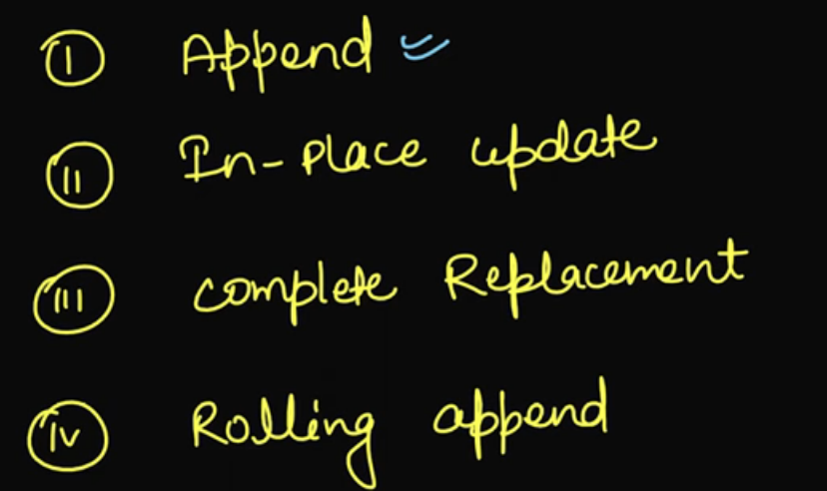

In Append we just add the new data, if it’s modified it will append it

In-place if data is the update version of existing record then we updated that row accordingly

In complete replace we do drop and load whole data again, it is not frequently used

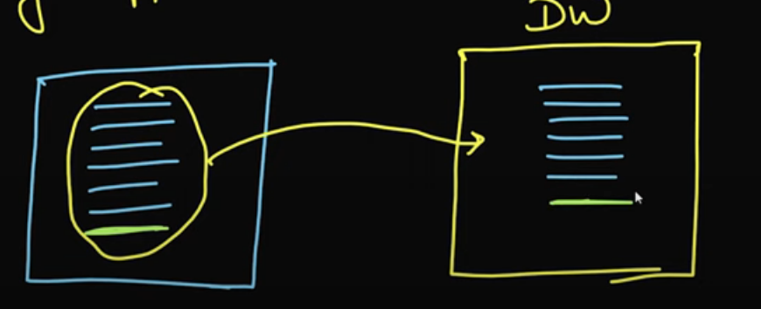

Rolling Update: Assume we need to store only 24 months data and we load data monthly and DW already has 24 months of data, then we append new data and remove old data, i.e first months data

Dimensional Modelling:

* 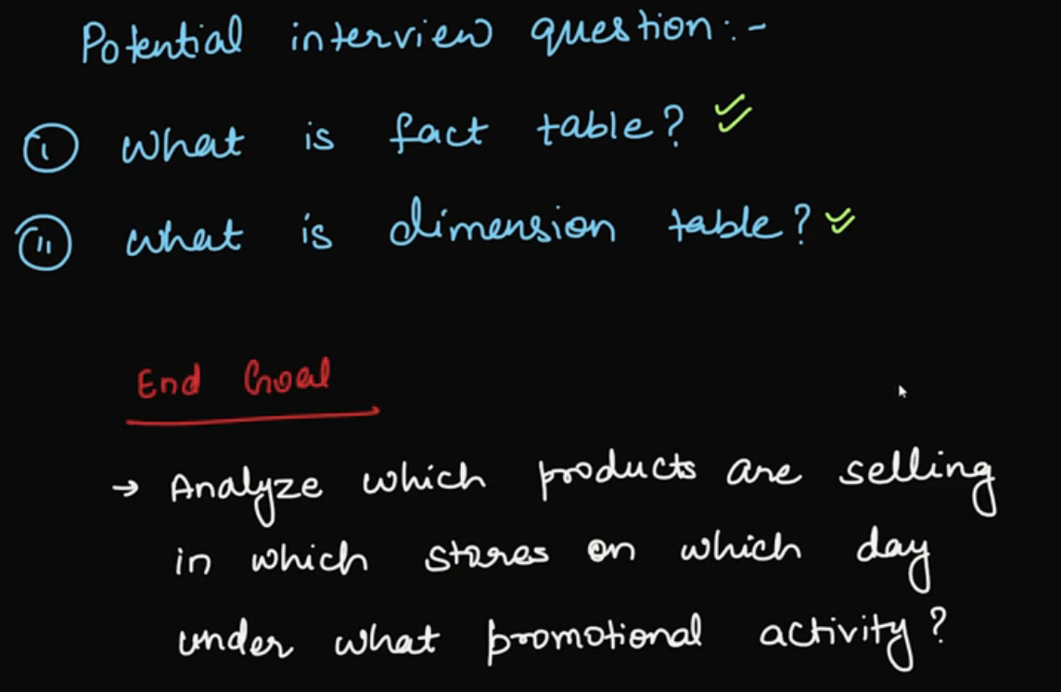

Facts & Dimensions:

* 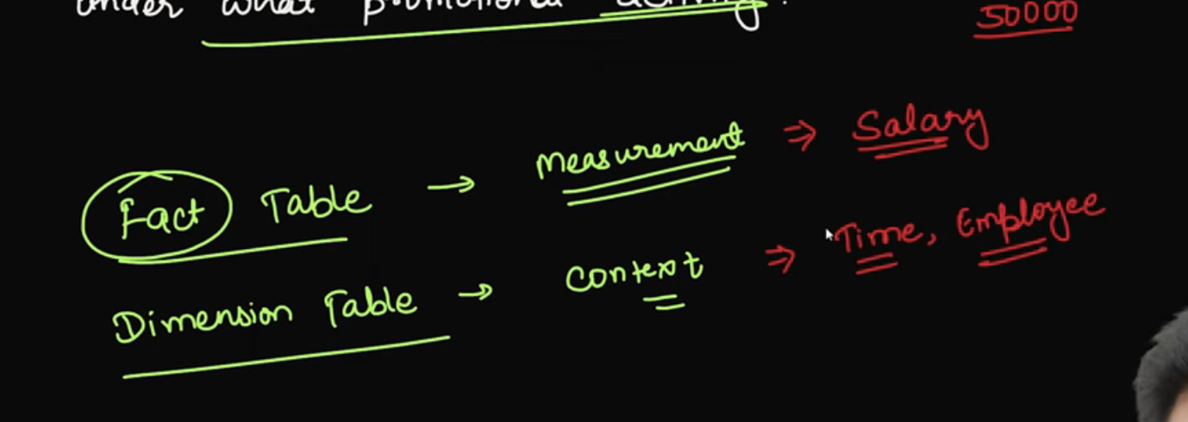

Facts gives you measurement/numerical values

Dimensions gives you context

If we takes 20000rs as salary, here salary is a fact and context of that which employee salary is a dimension based

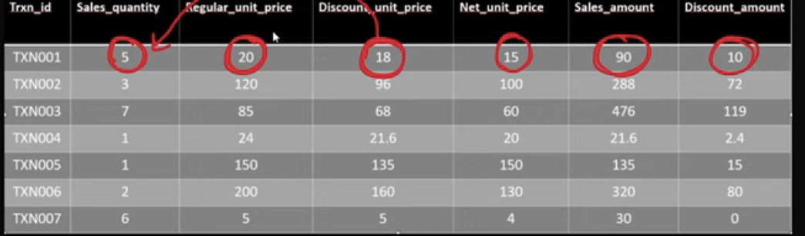

* 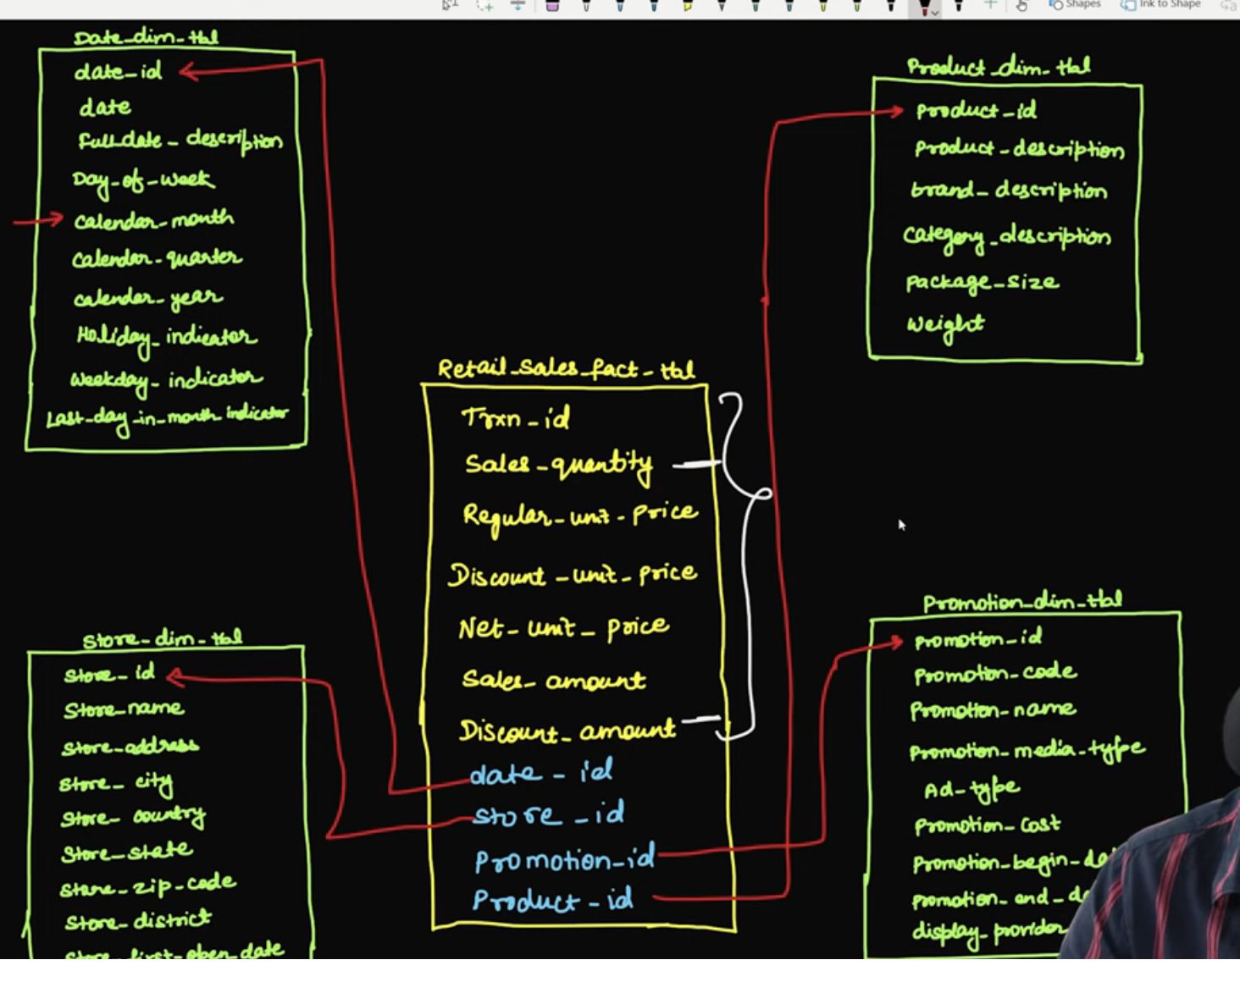

How to Select Fact Tables and its columns:

* 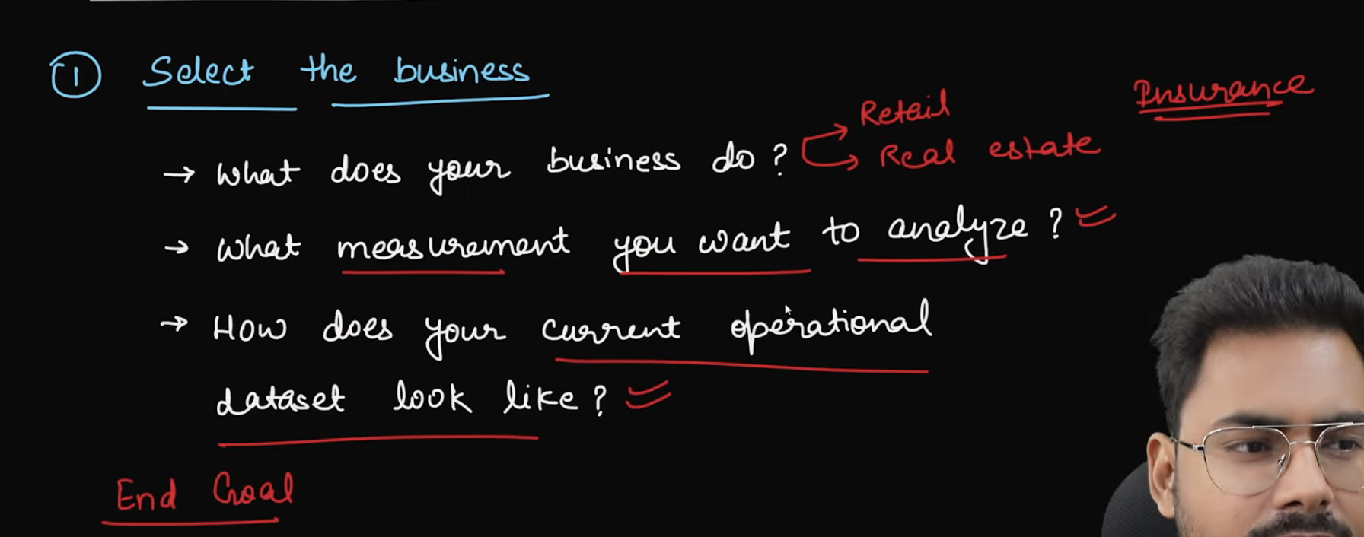
* 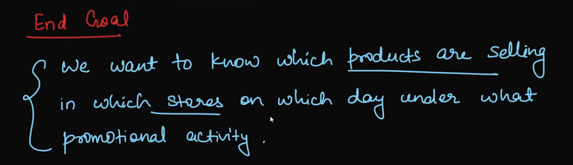
* Level of grain means how a each row of record gives information
* 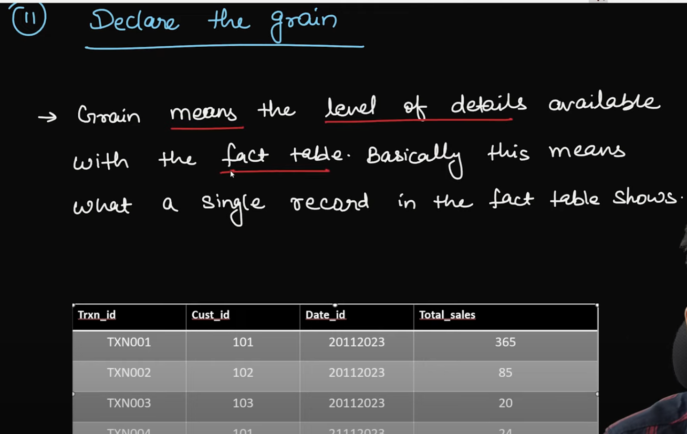
* 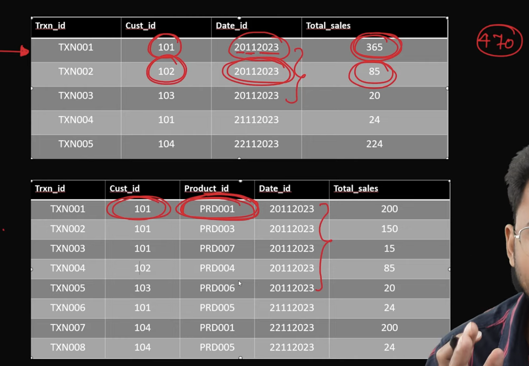
* 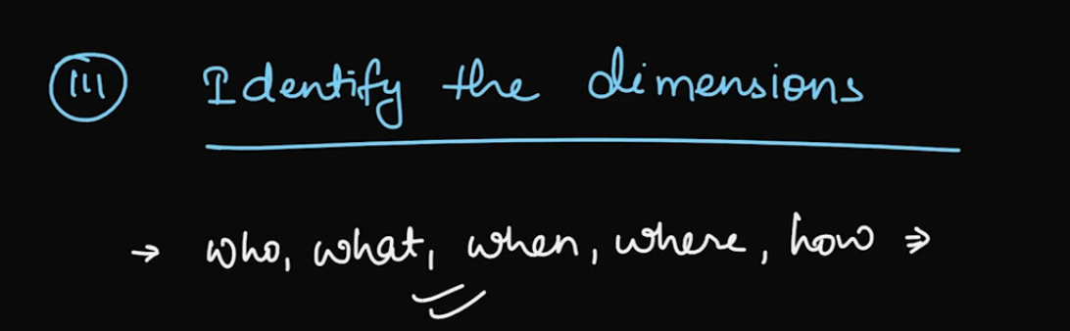
* 

Derived Fact is a column which is derived from other columns:

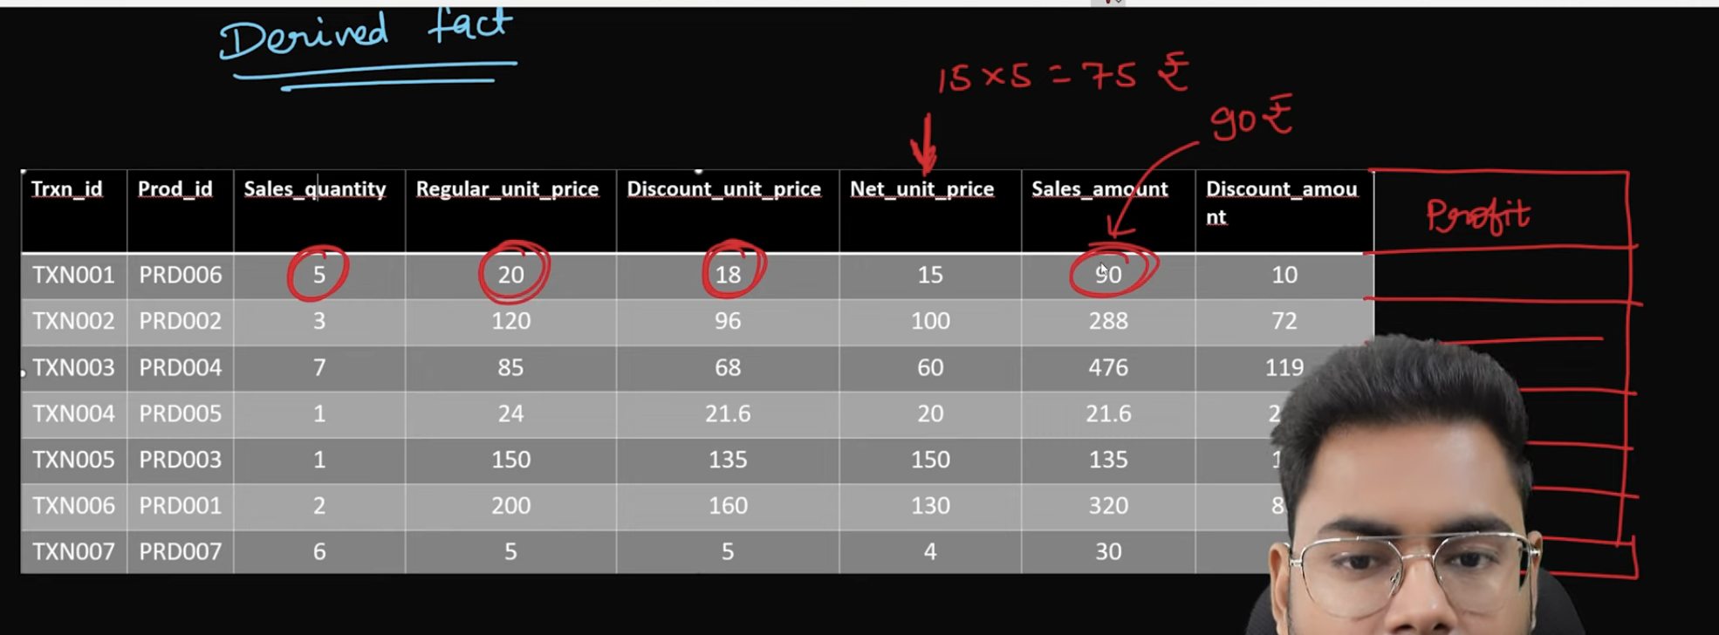

Types of Facts in Facts Table:

* 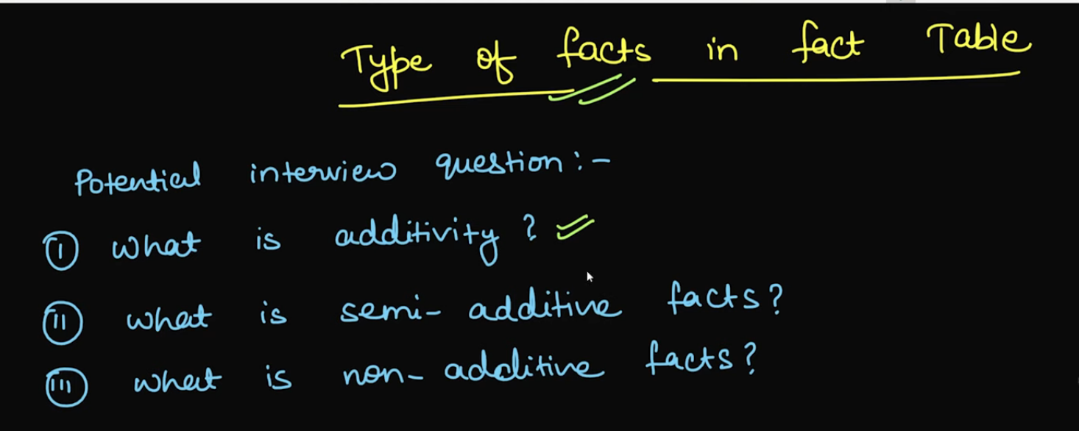

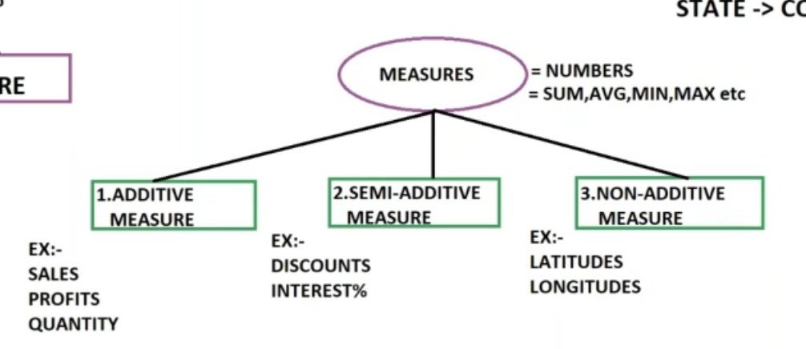

1. Additive
2. Non-Additive
3. Semi-Additive
4. 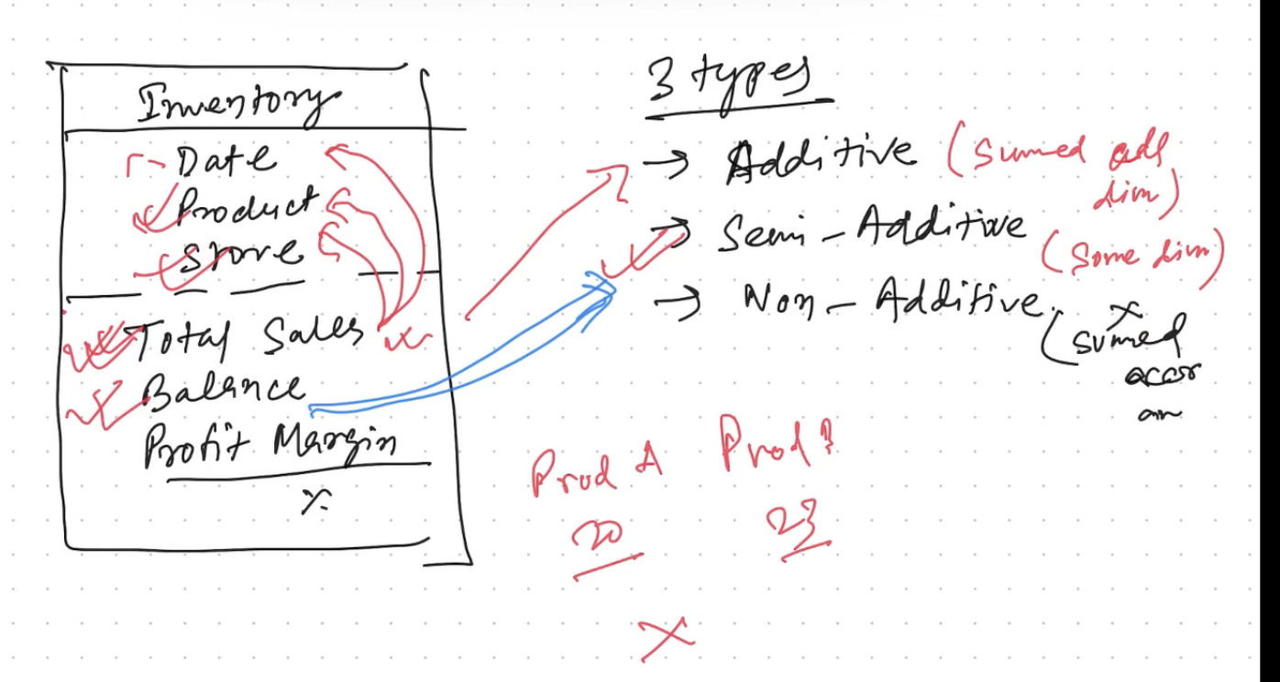

Additive means summing up or adding up

* 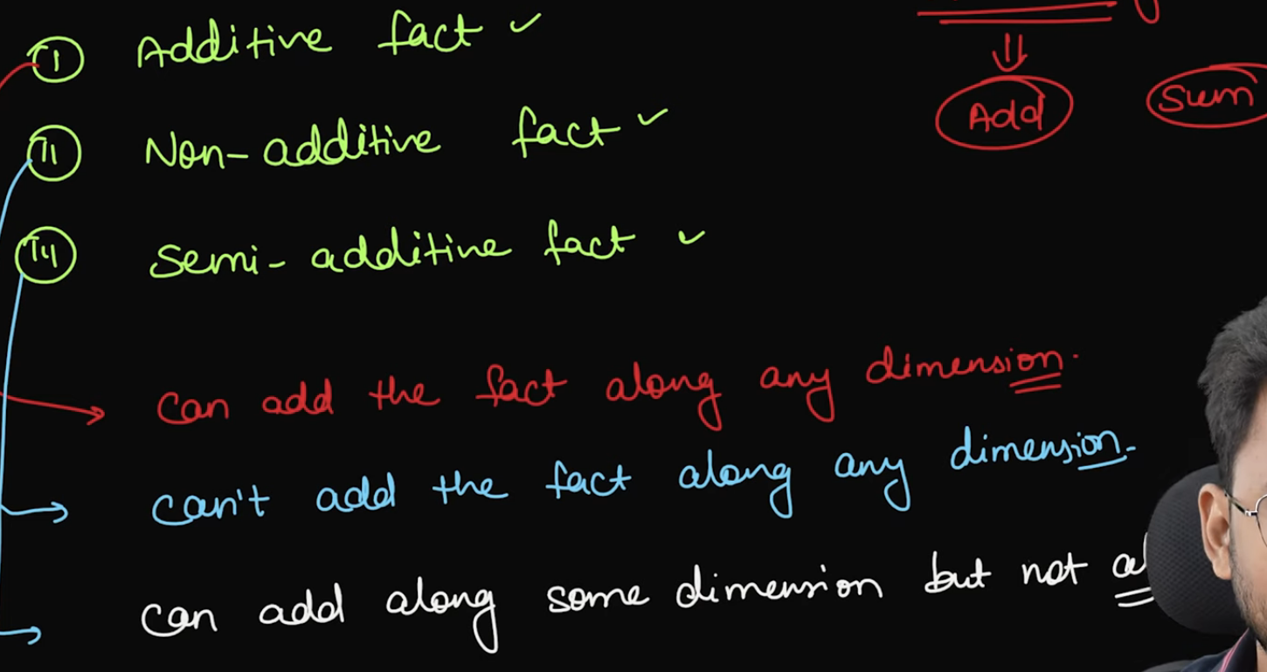

Additive

On Facts columns if I do any aggregation and

* 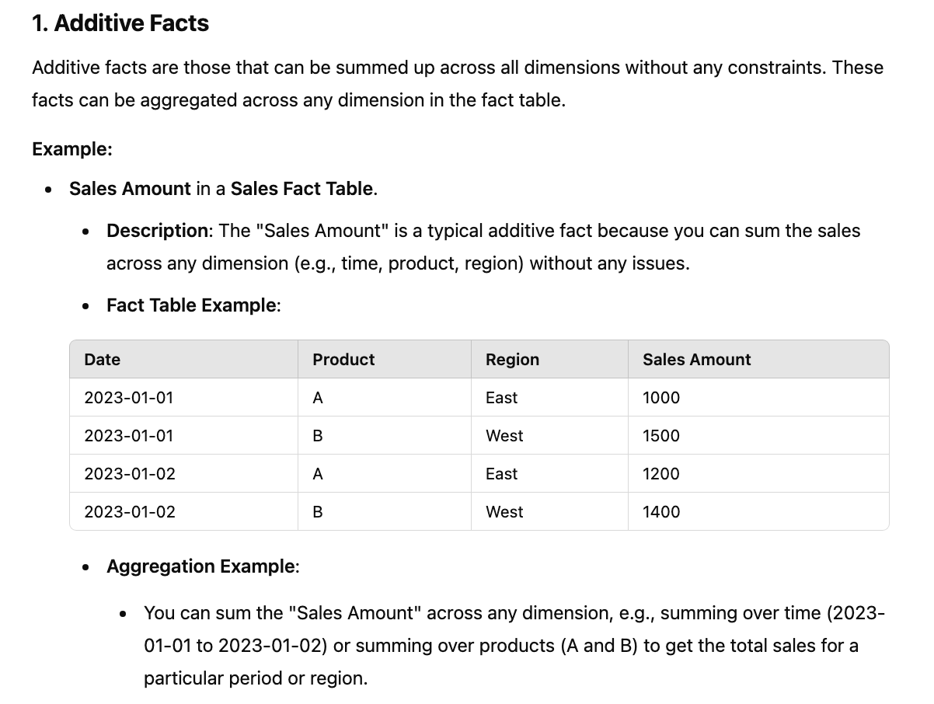

Non-Additive:

* 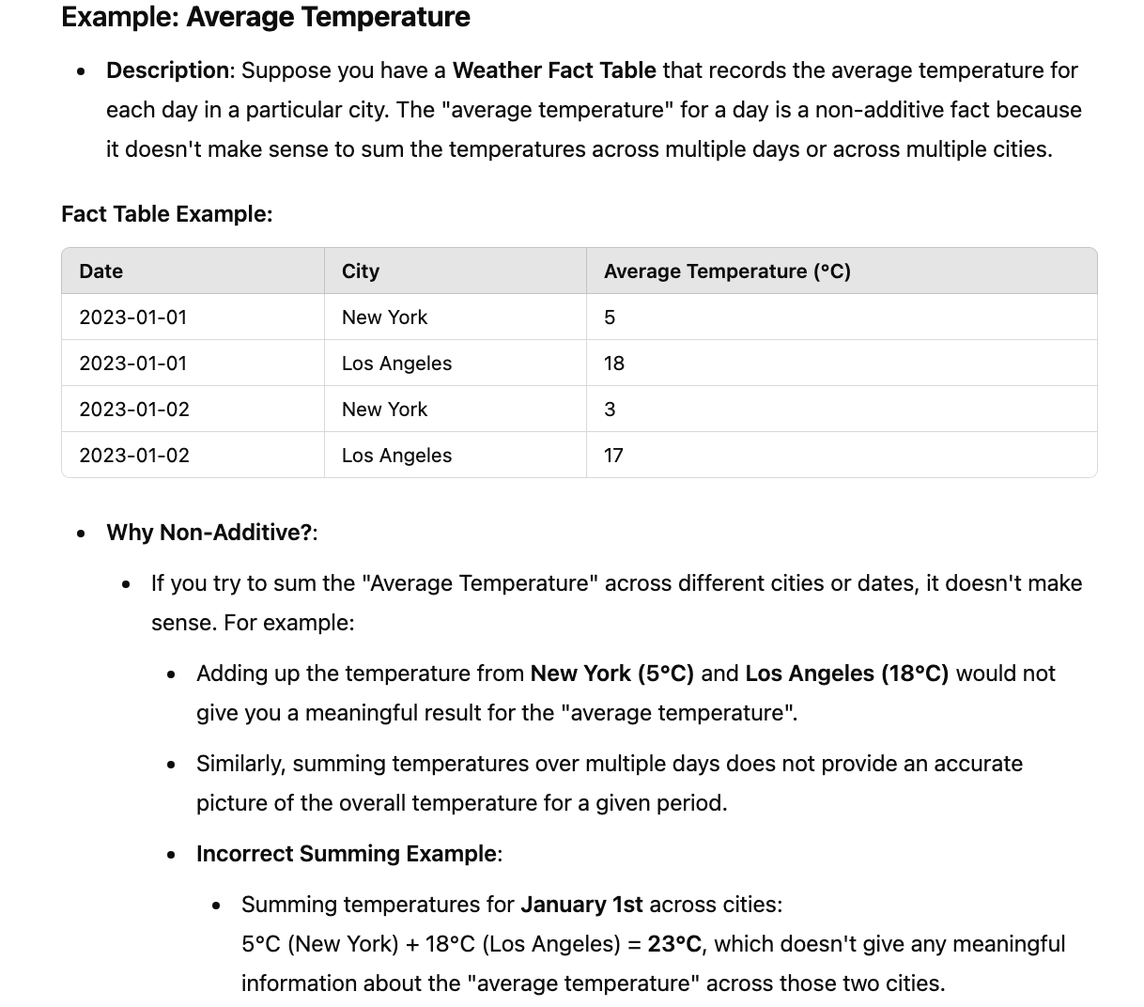

Semi-Additive:

* 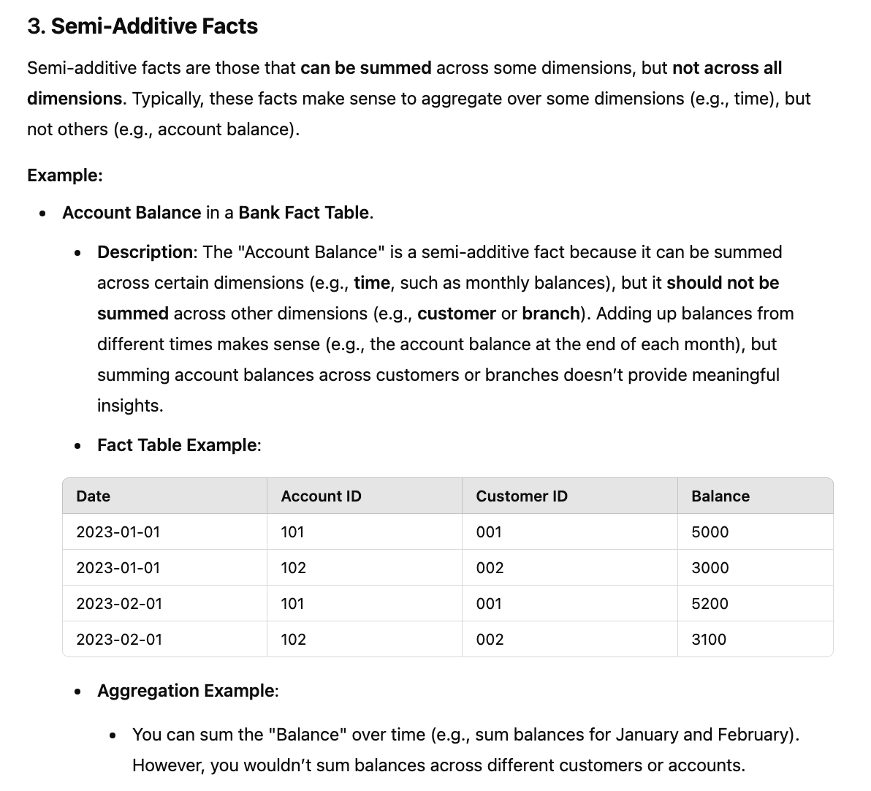

Cumulative Fact Table: If fact table contains only additive measure, then such a table is called Cumulative Fact Table

Snapshot Fact Table: Combination of semi-additive & non-additive

Factless Fact Table: Contains only FK

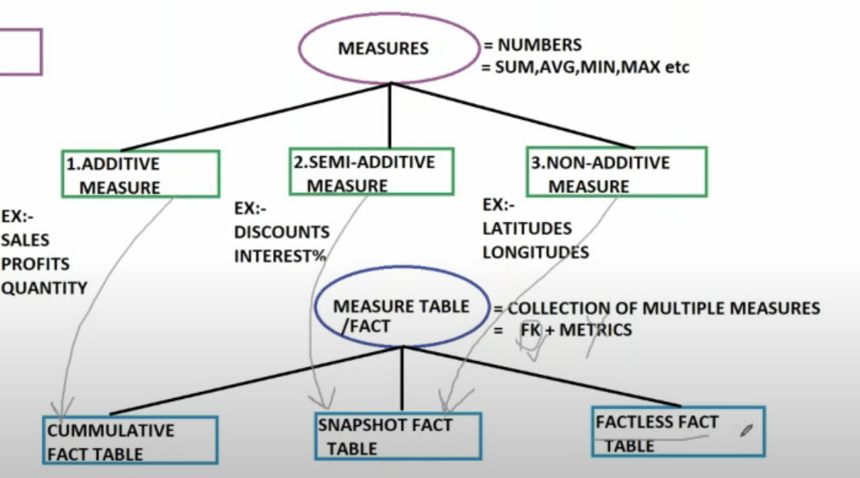

Sample DESIGN

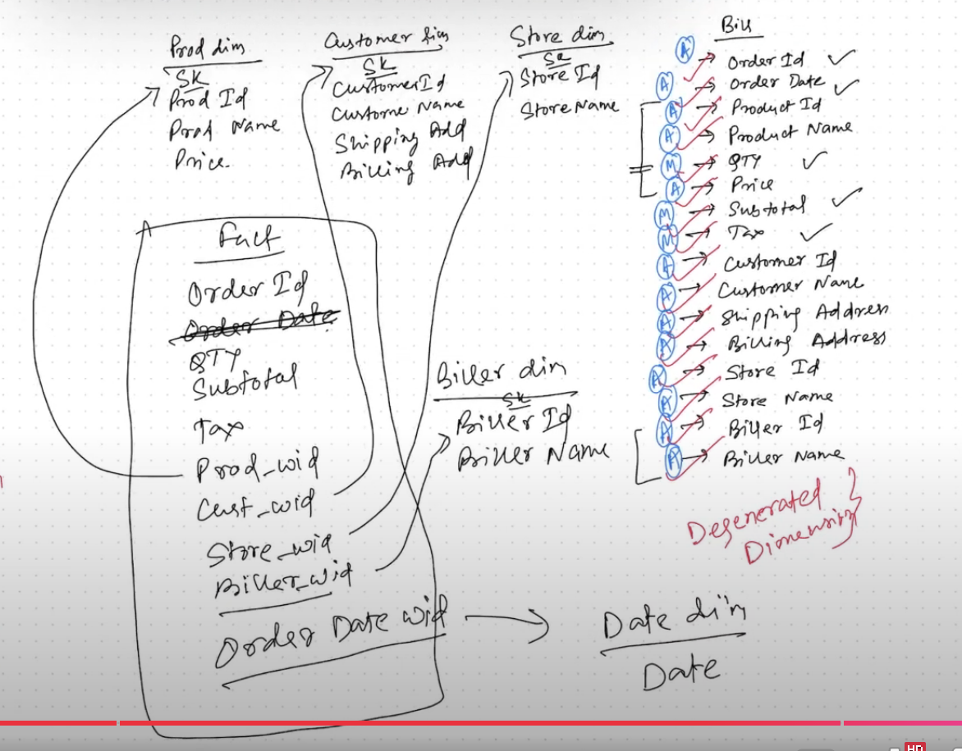

* Types of Fact Table
* 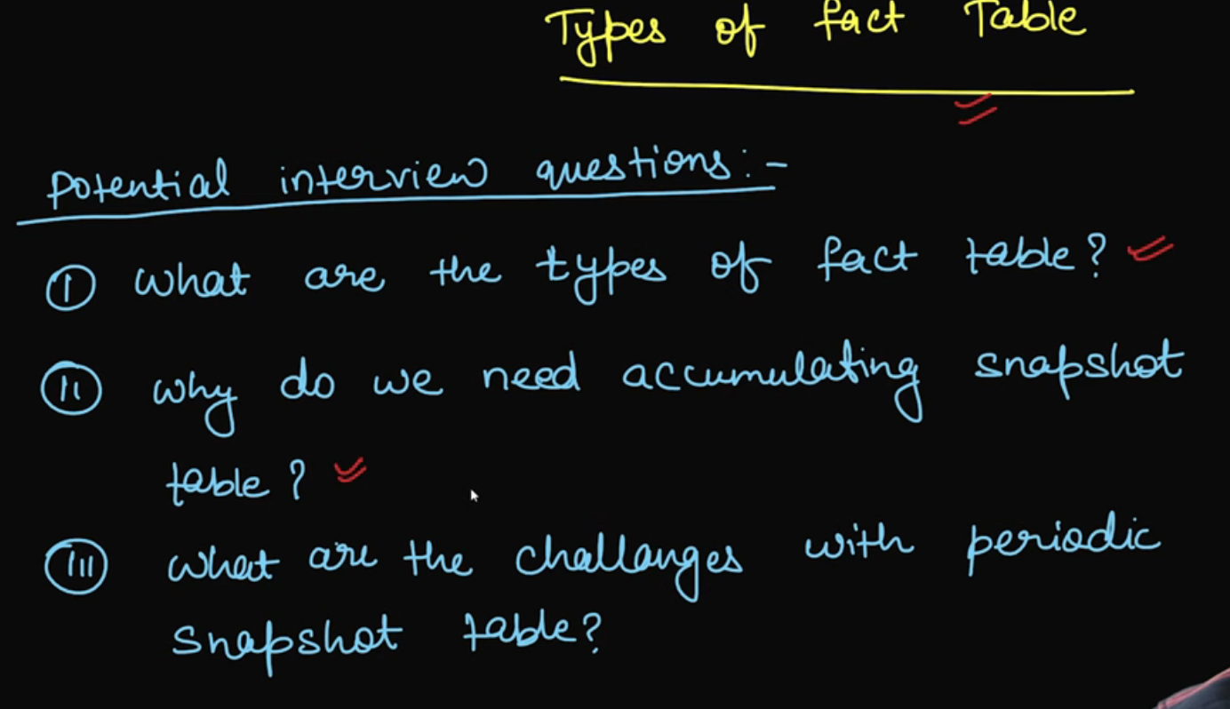

Transaction Fact Table:

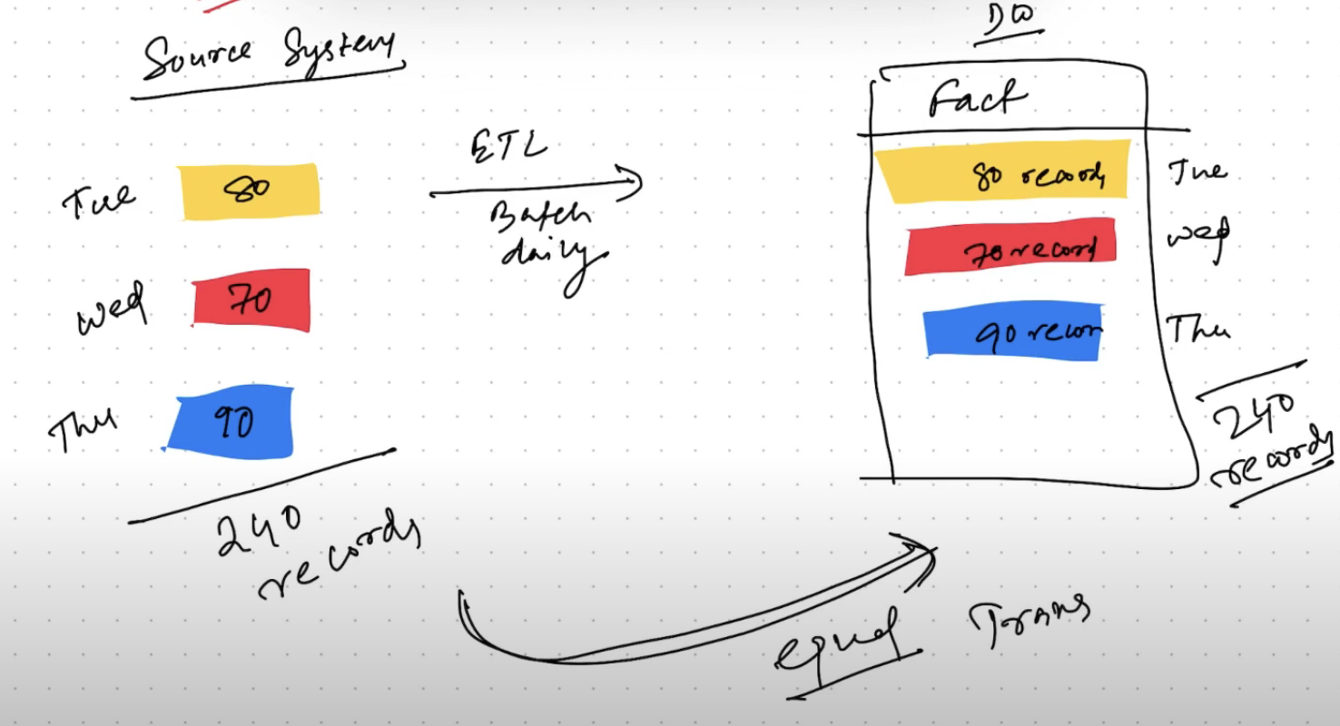

It captures all the data from present in source data at most granular level

* 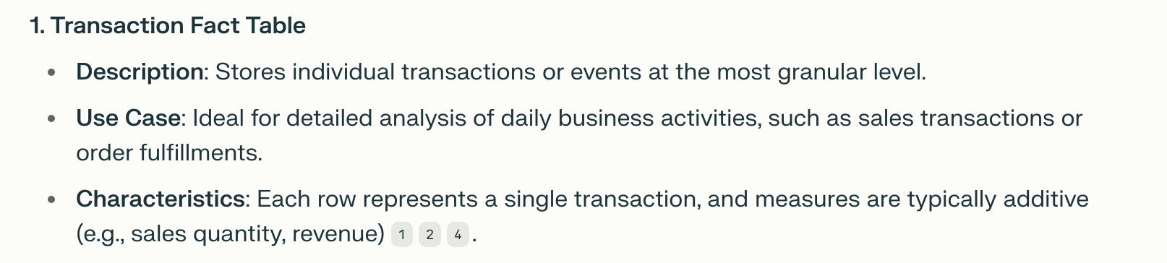
* 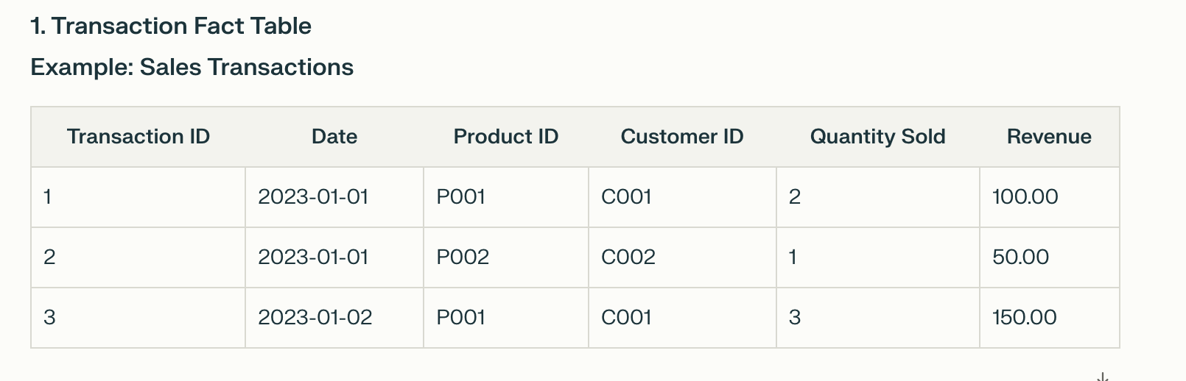

Periodic Snapshot Fact Table:

* 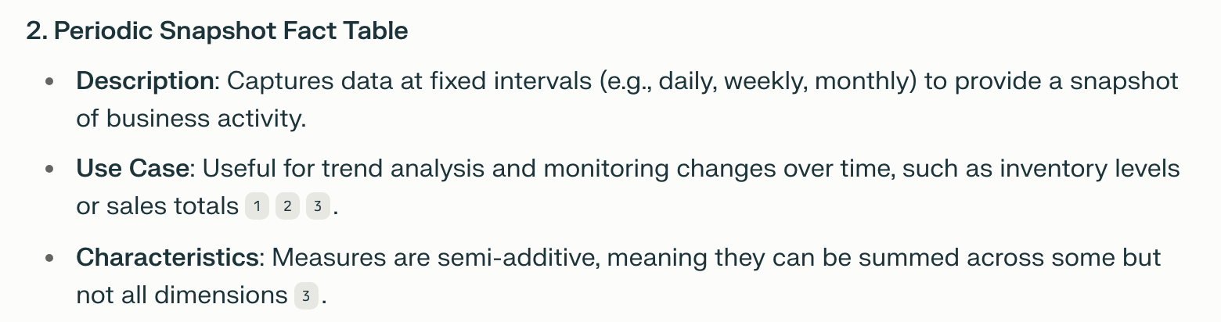
* Less granular compared to transaction based
* 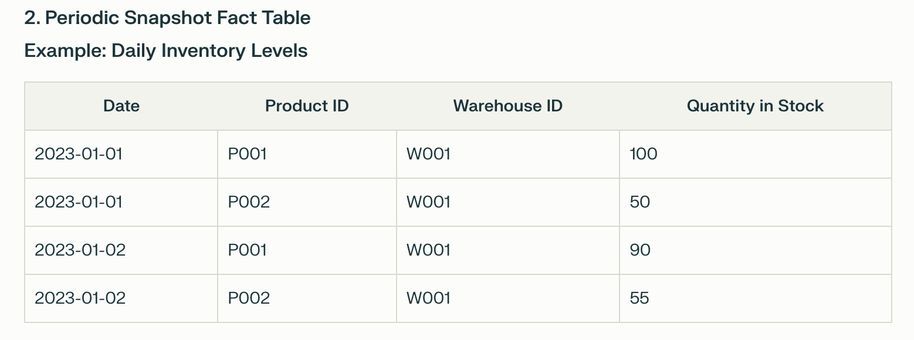

**Accumulating Snapshot Fact Table**

* 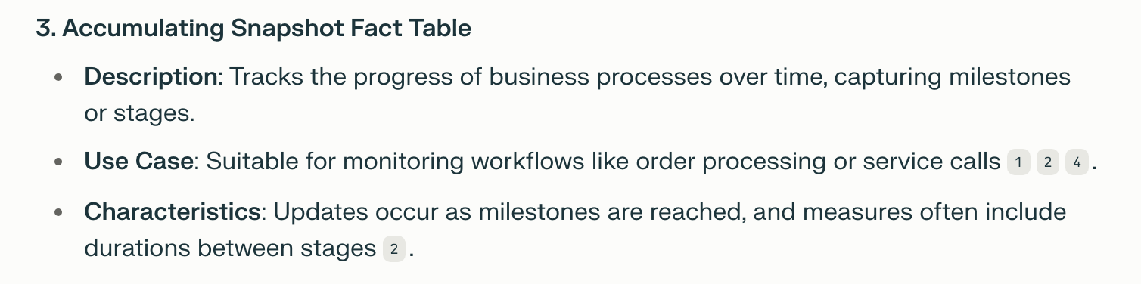

Here we take snapshot of fact table on regular interval, this kind of fact table is useful in capturing rate of product sales over a period

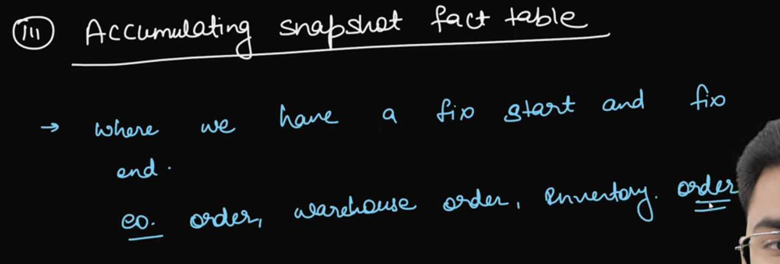

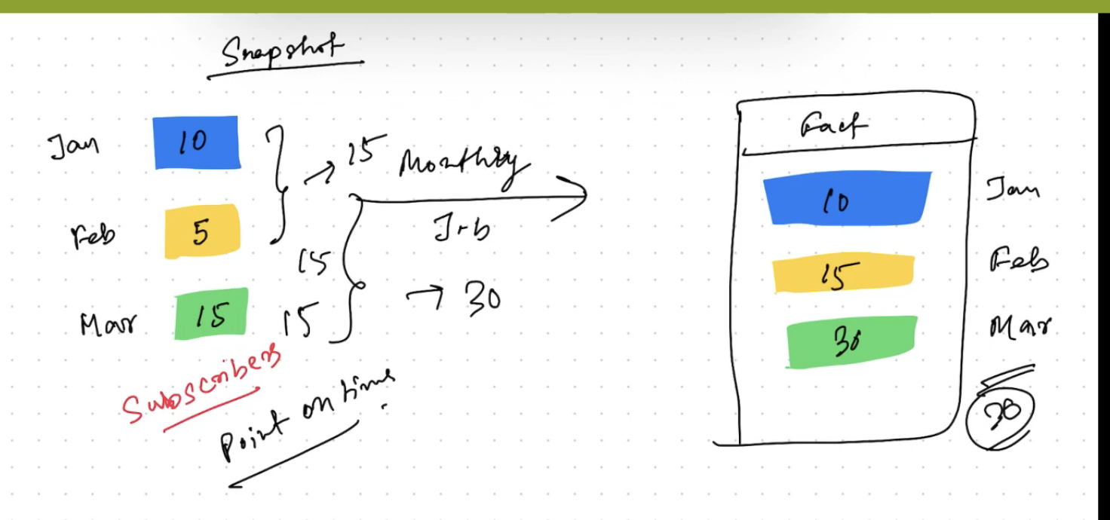

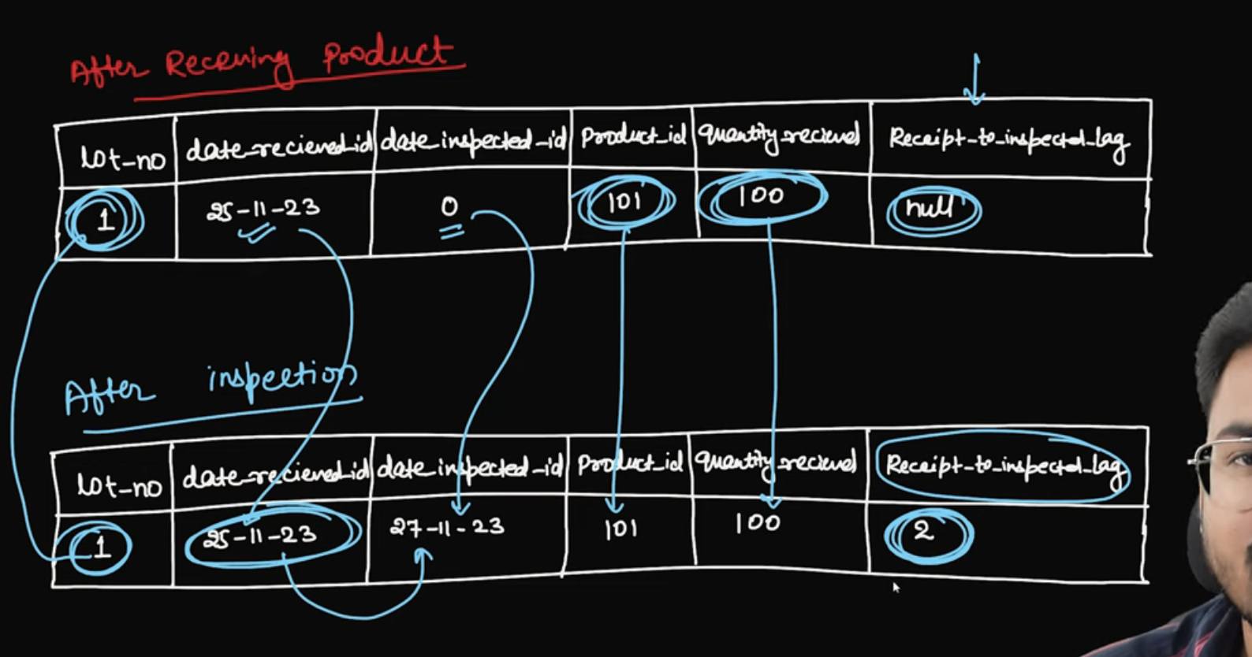

Here we update same record, another example is order status tracking

Factless-Fact Table: It will not give any measurement, entire record itself is considered as fact

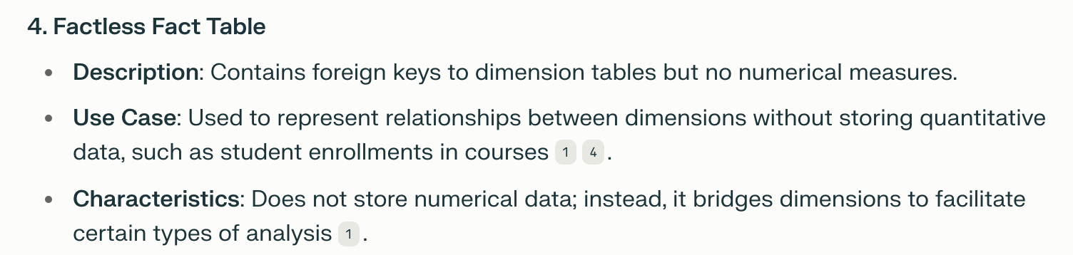

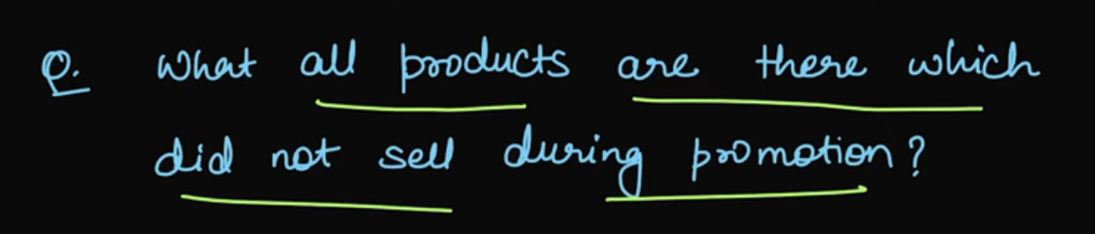

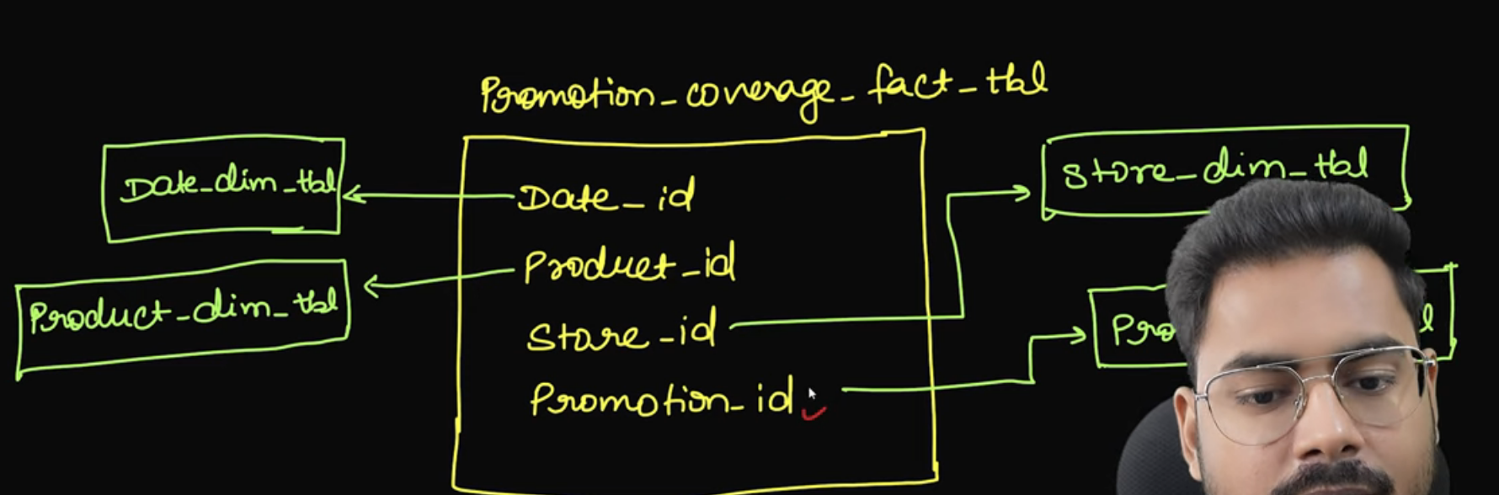

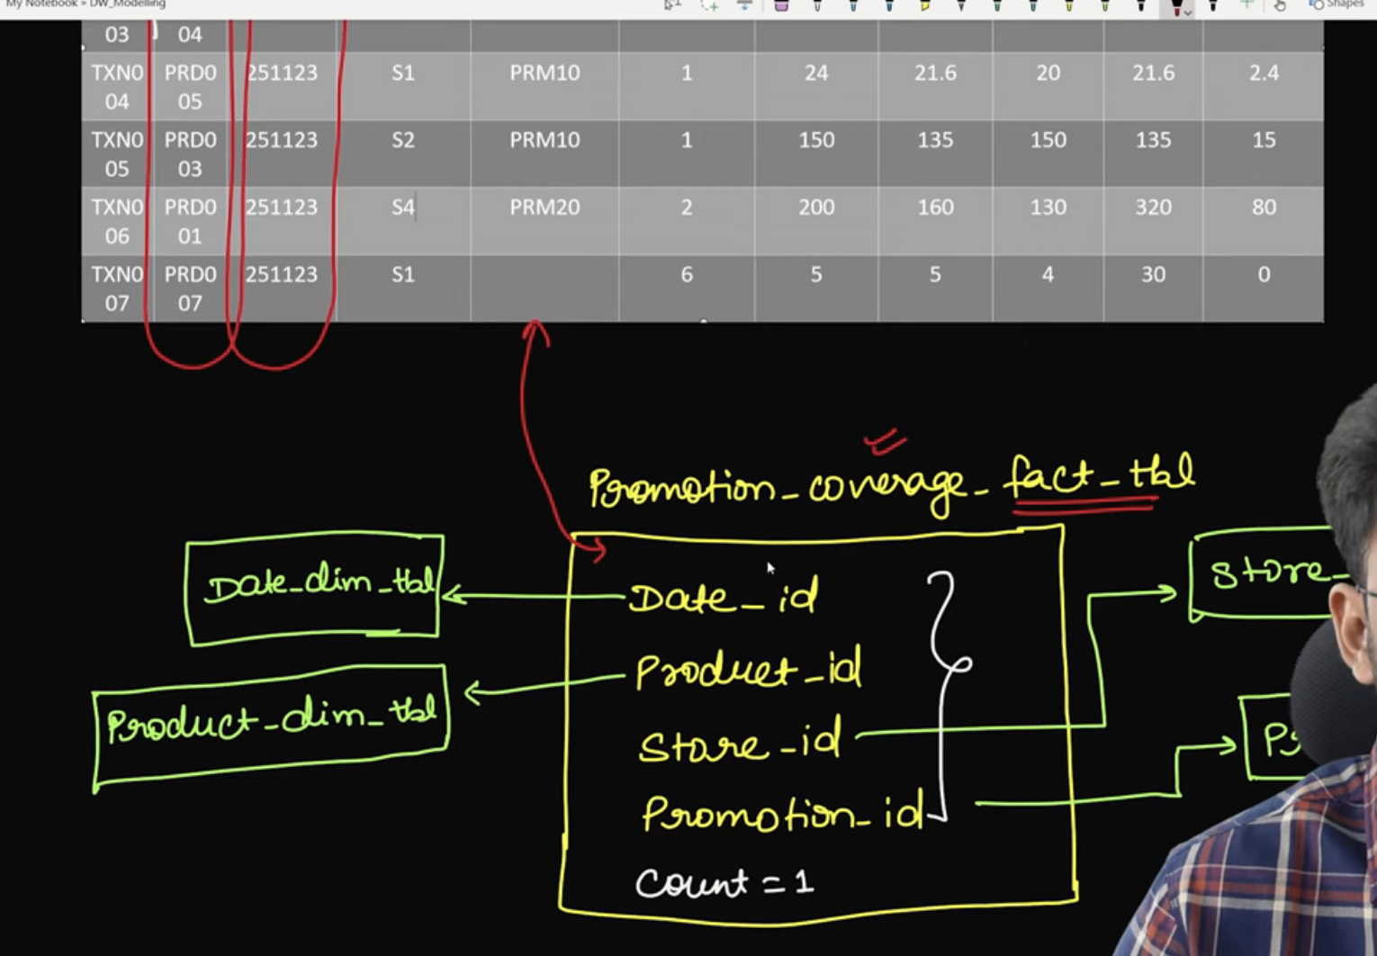

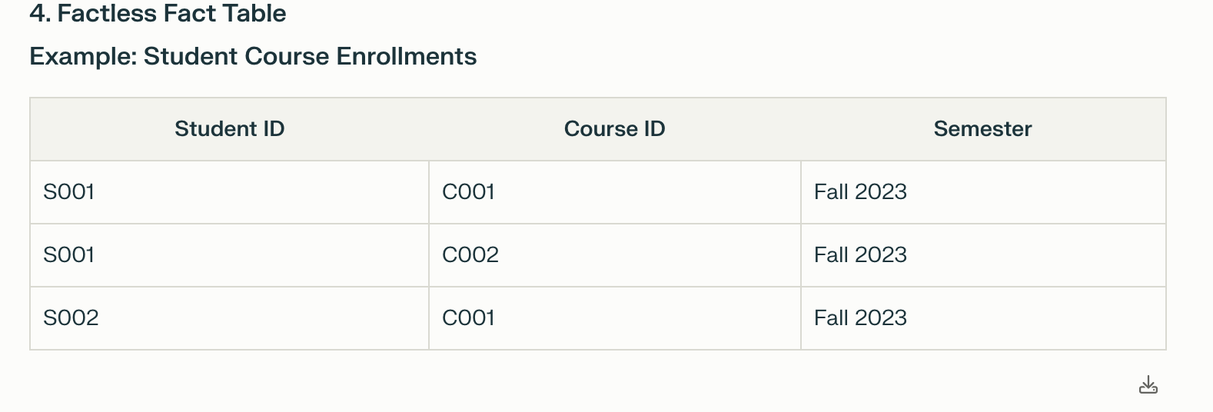

* 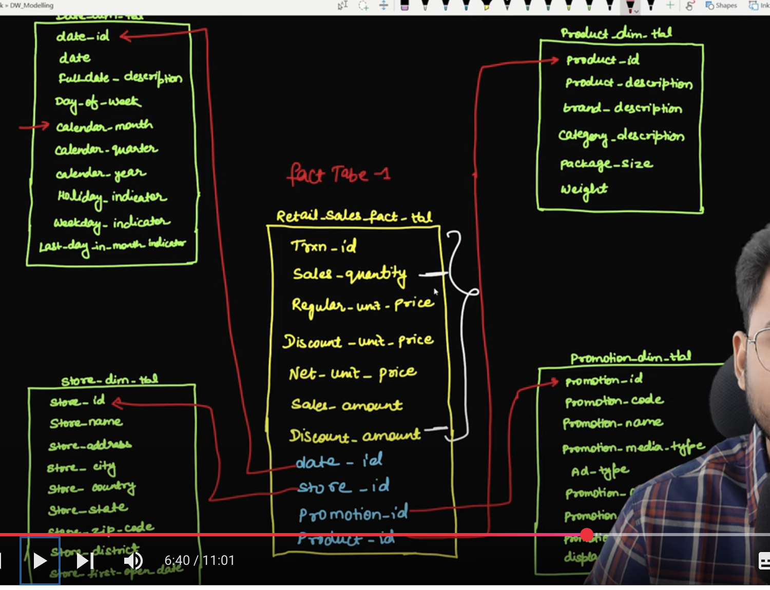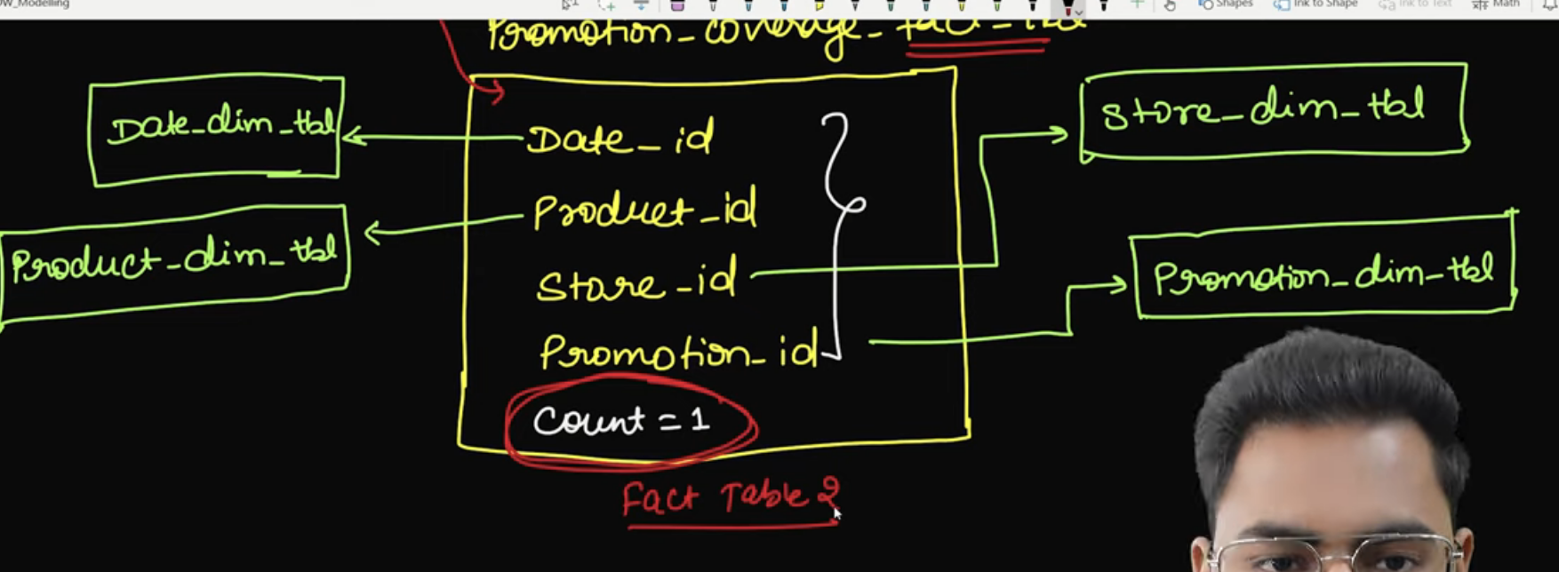
* If there is record with count then that itself indicates that product_id was not part of promotional activity

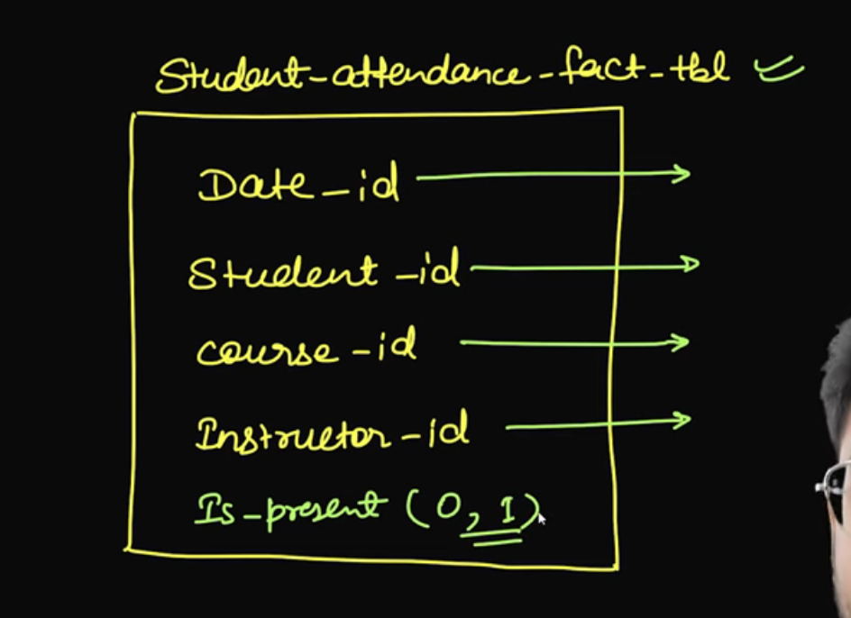

Here the record itself indicates that student was present or not

Date Dimension:

* 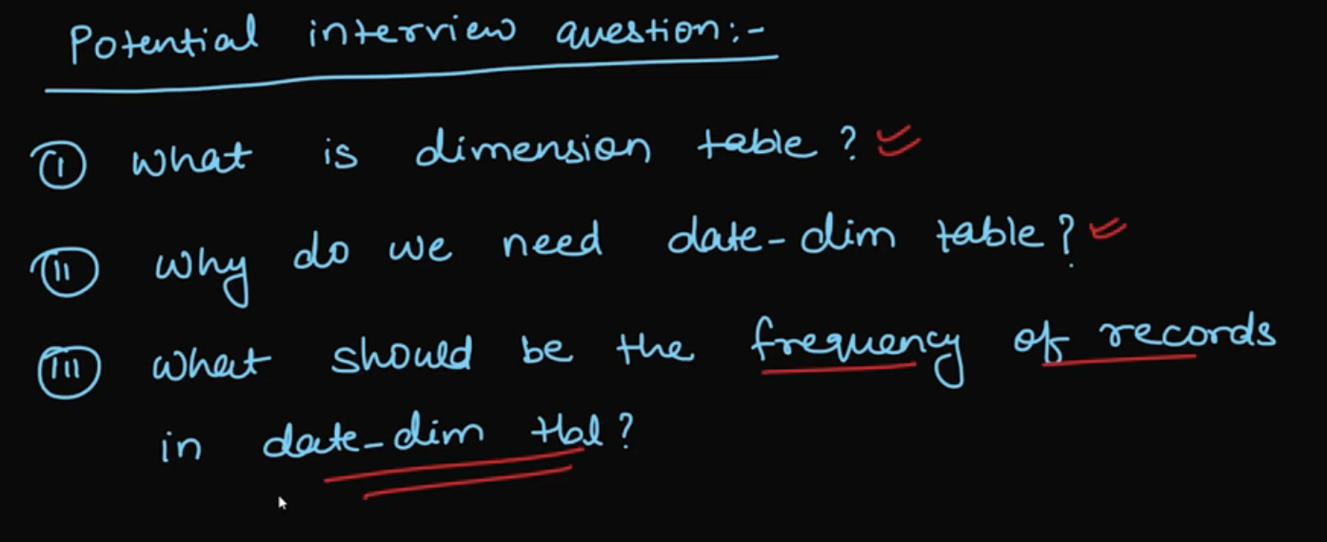
* 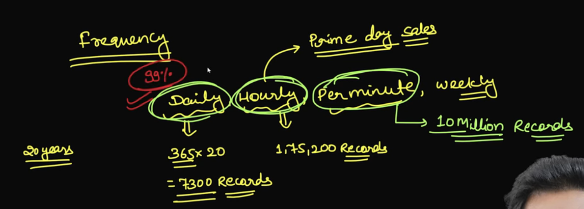
* 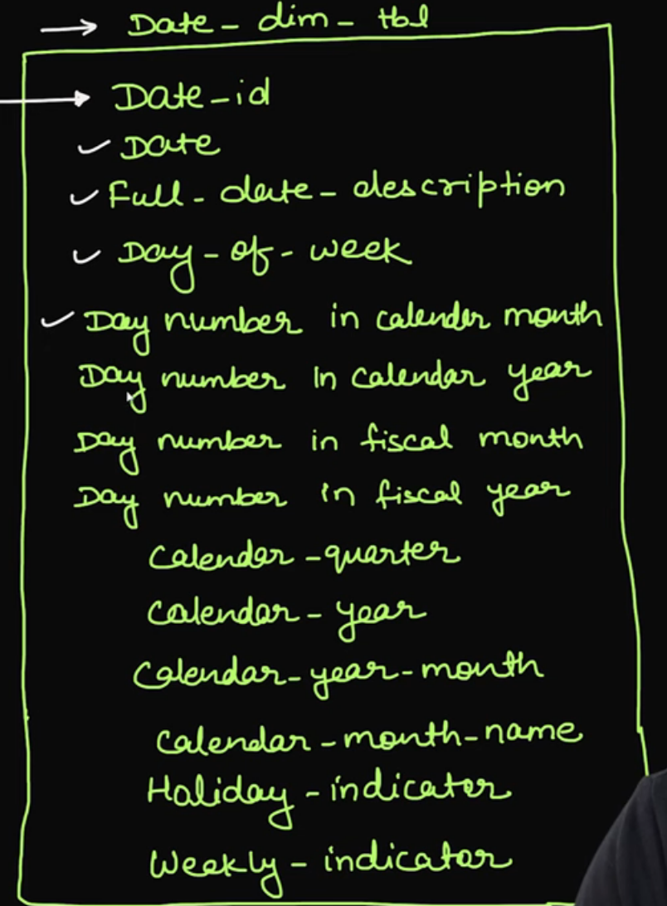
* 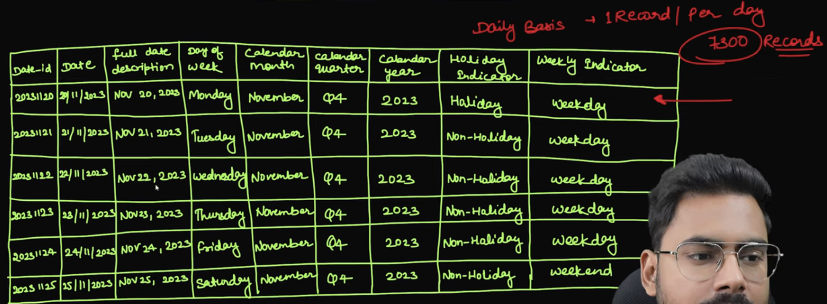
* Product Dimension Table:
* 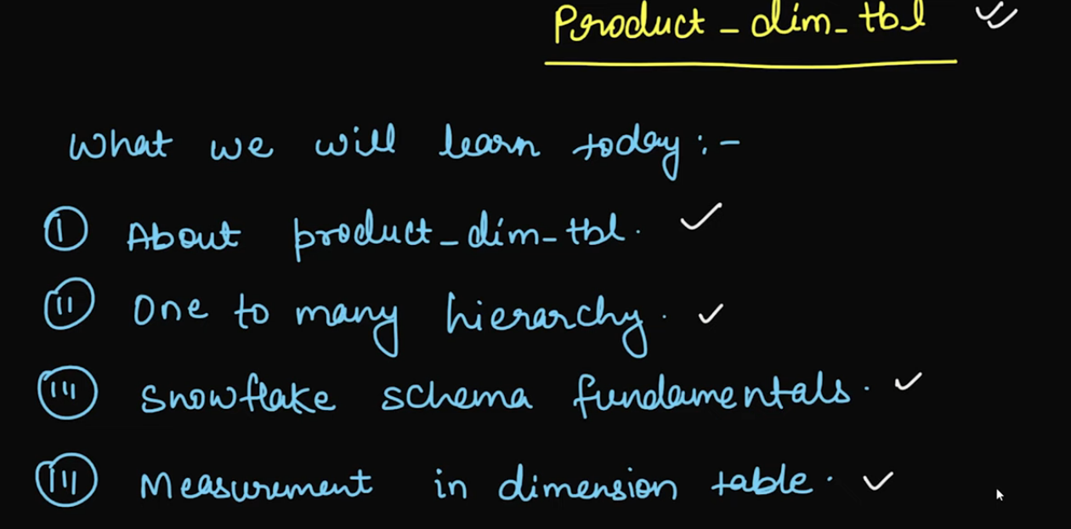
* 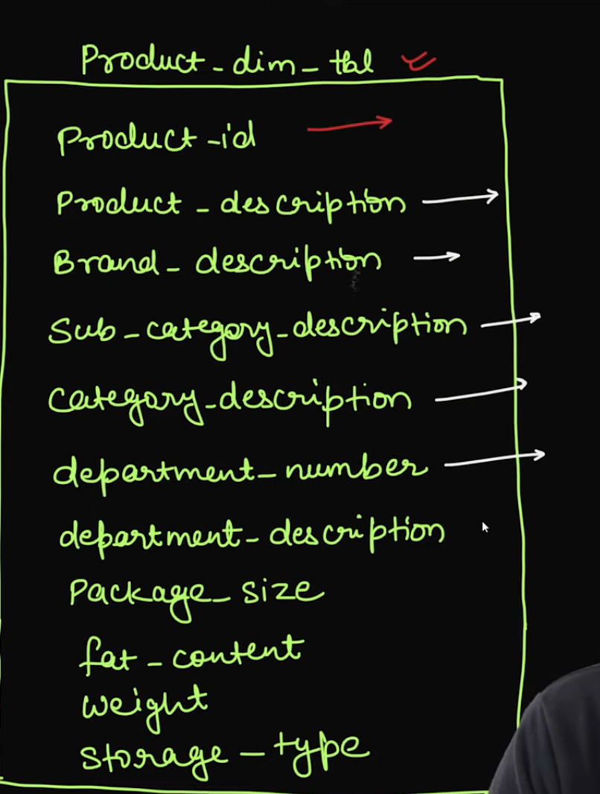
* 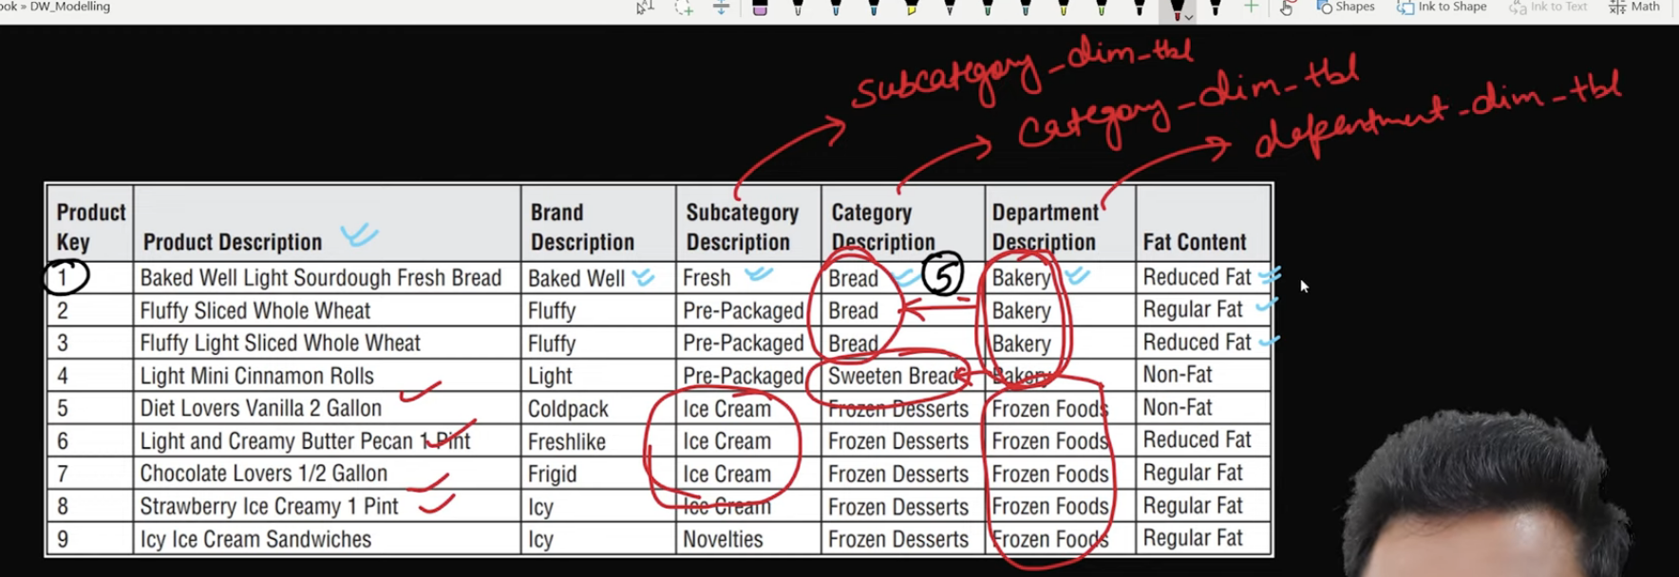

In snowflake schema we split dimension table into further small tables

1 to Many Hierarchy



* 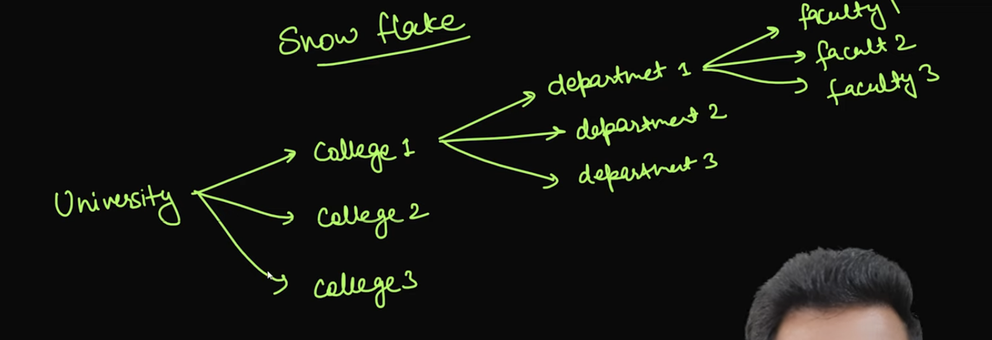
* 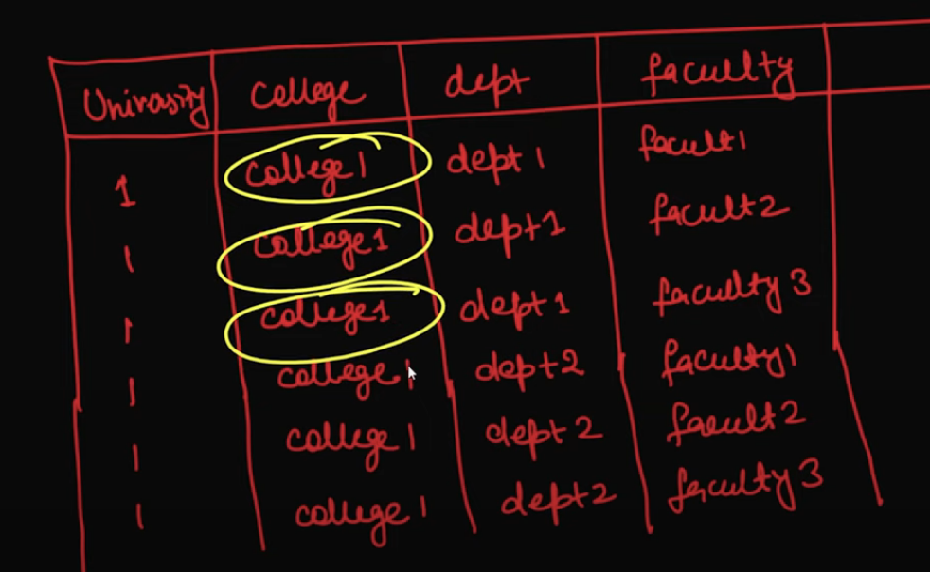

There is lot of redundant data

Rollup, Roll Down, Drilling up, Drilling Down:

* 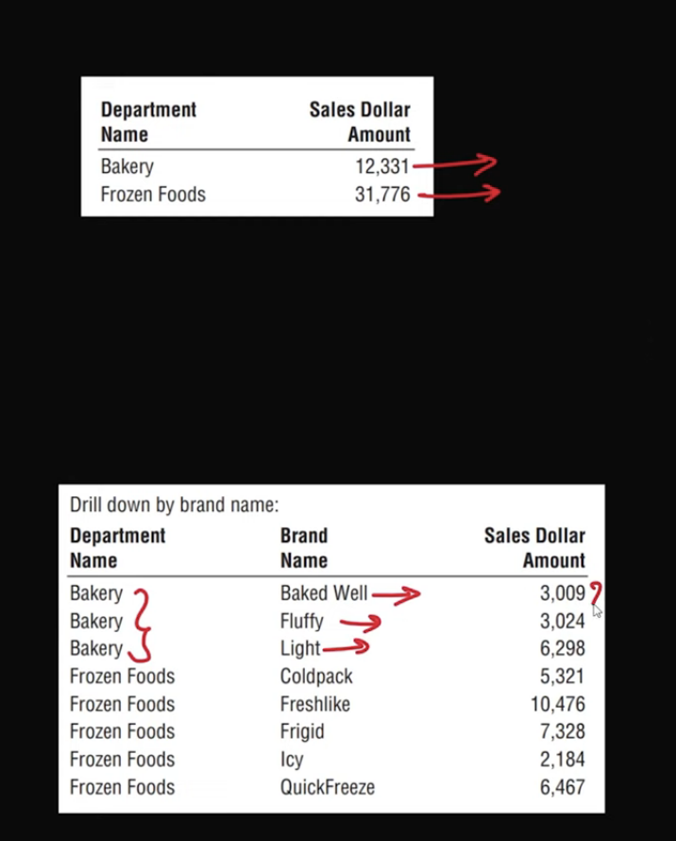 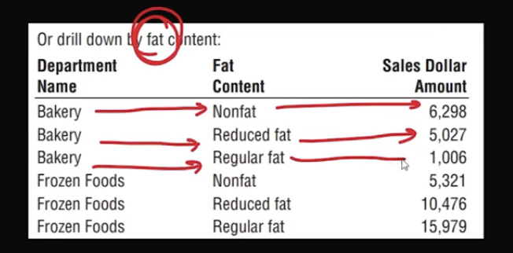
* 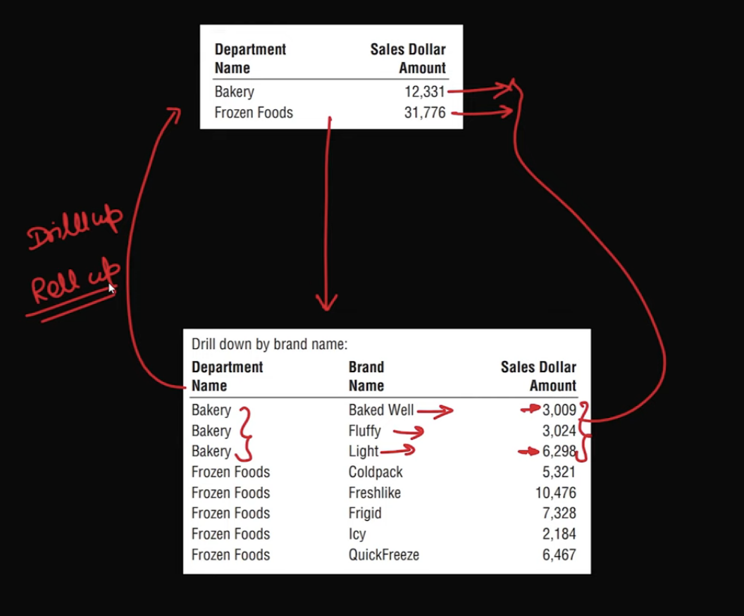
* Rollup/Drill Up means don’t go in-depth
* Rolldown/Drill Down means go in-depth

Types of Dimensions:

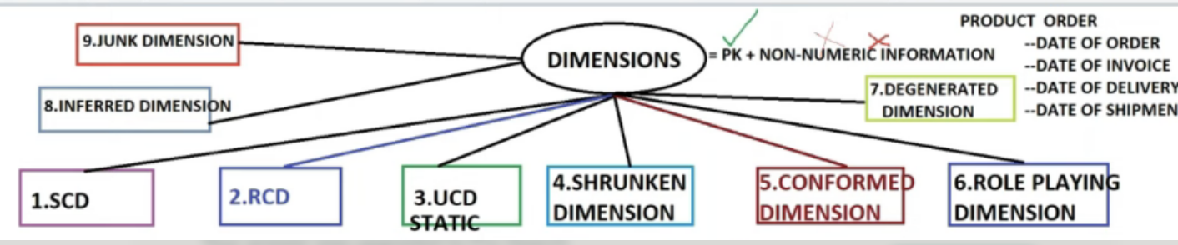

* 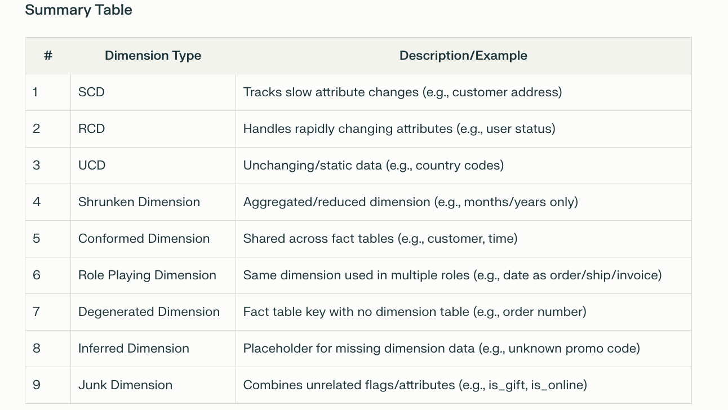

Conformed Dimension: Same dimension is used at multiple places, example: date dimension, it should be same table not replica or copy of it, it should be same table

* 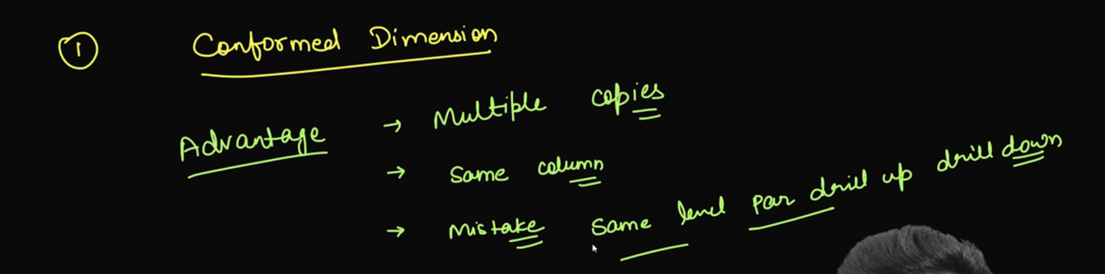
* 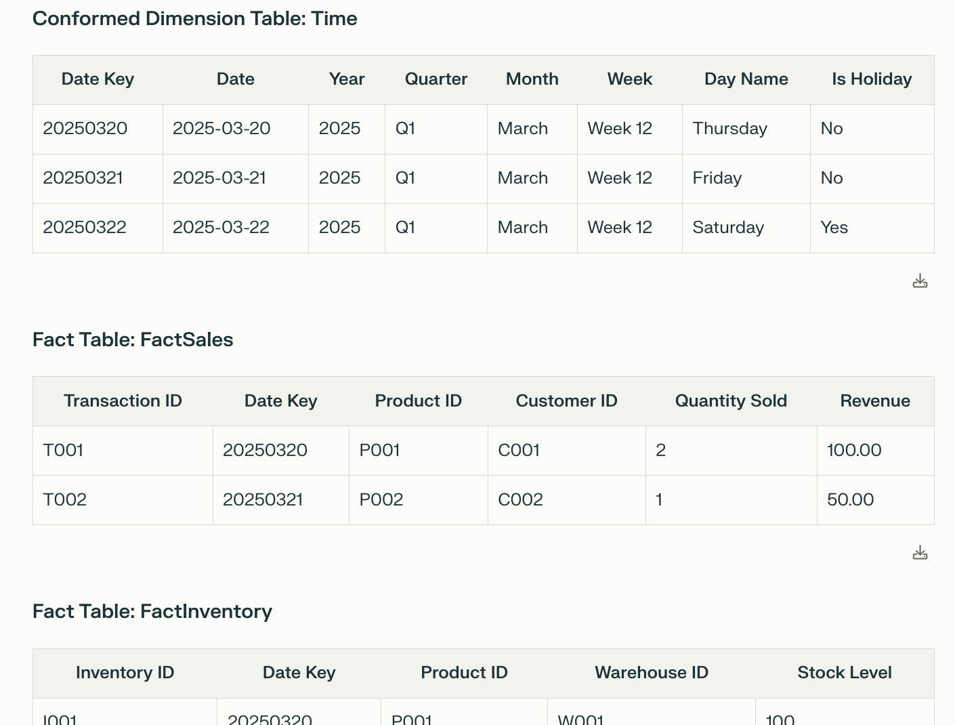

Date dimension is used at multiple places

Role Playing Dimension:

* A **Role-Playing Dimension** is a single dimension table that is reused multiple times in the same fact table for different purposes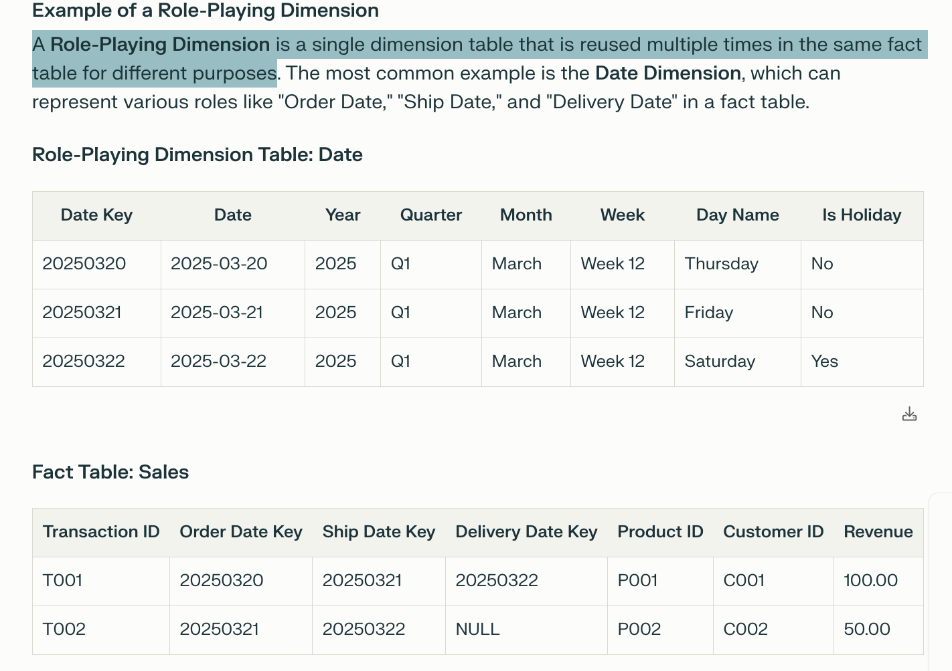

Junk Dimension:

* A **junk dimension** is a dimension table that consolidates low-cardinality attributes (e.g., flags, indicators, or text fields), These attributes are grouped into a single table to simplify the schema and reduce clutter in the fact table.
* Suppose I want to store info like payment_mode, promotion then for 1 billion records size can become 4 billion bytes
* Here we merge all these small data and make junk dimension

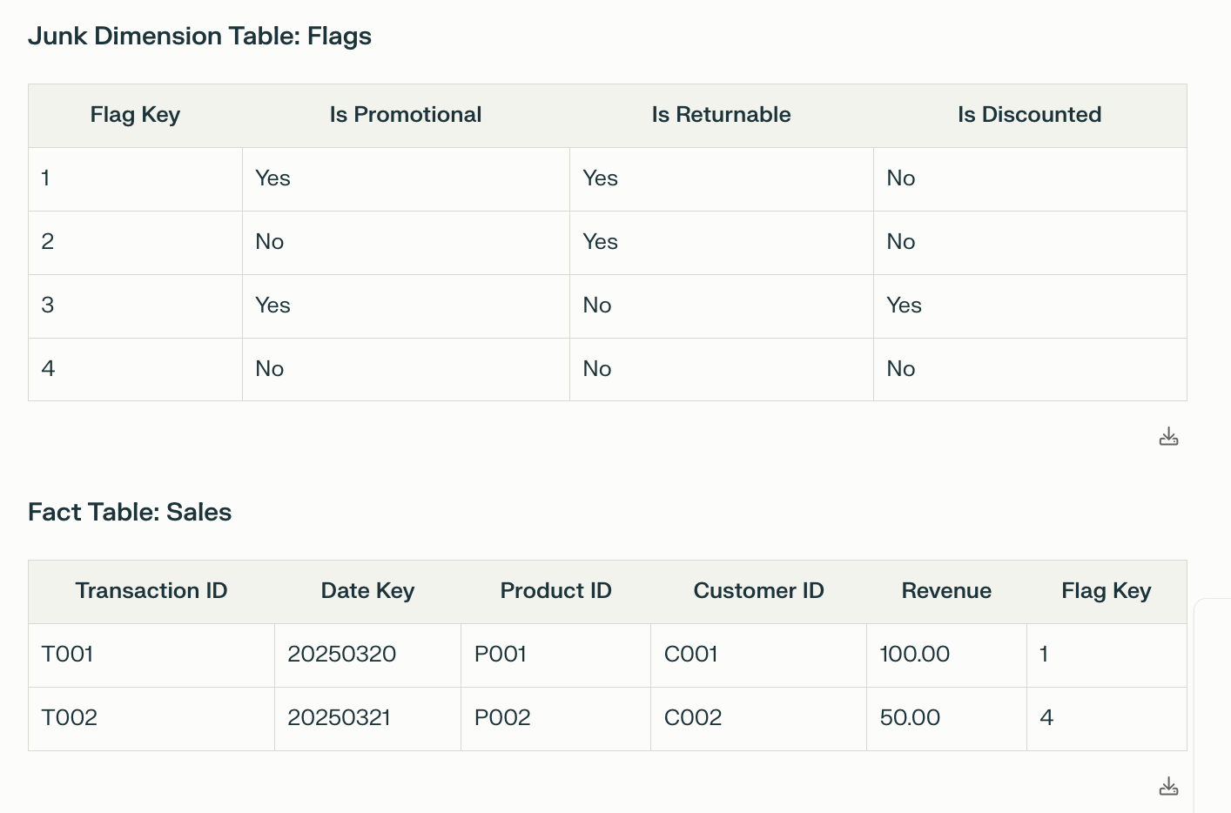

* Star Schema & Snowflake Schema:
* Consider Transactional table
* 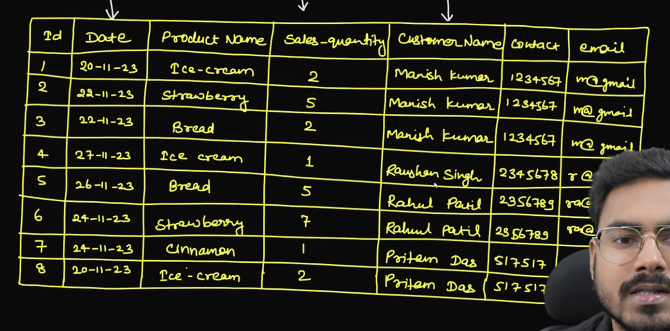
* Here date field can be made as date dimension, product name as product dimension and customer name as customer dimension
* 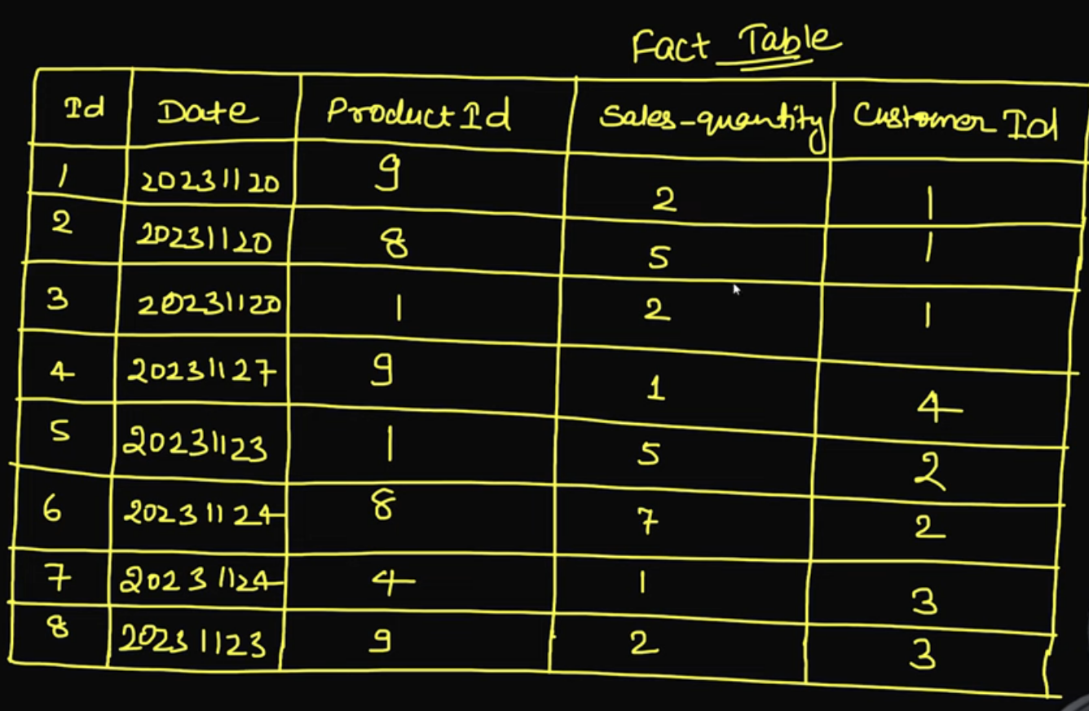

Issues with regular transaction table:

1. Data Redundancy

* 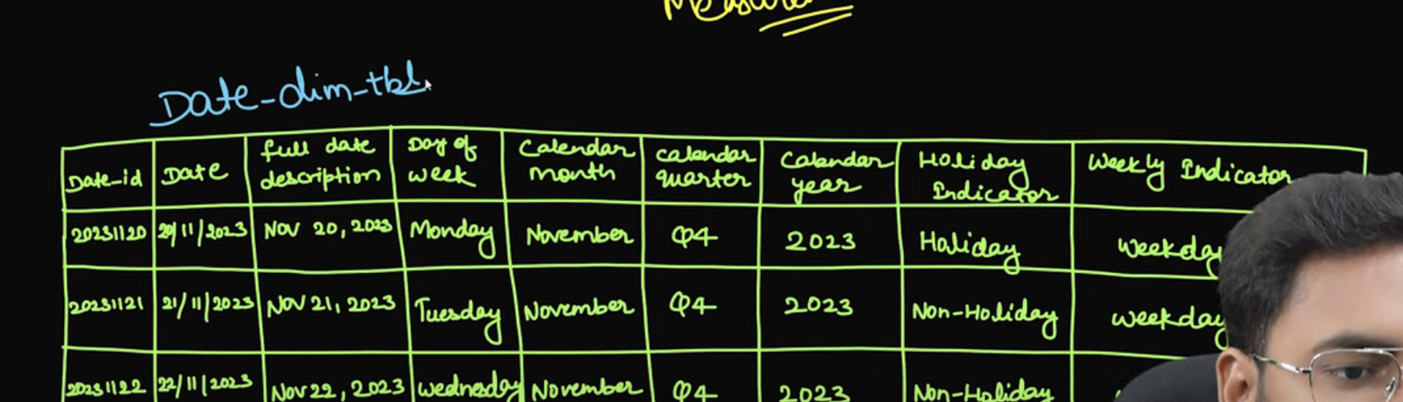
* 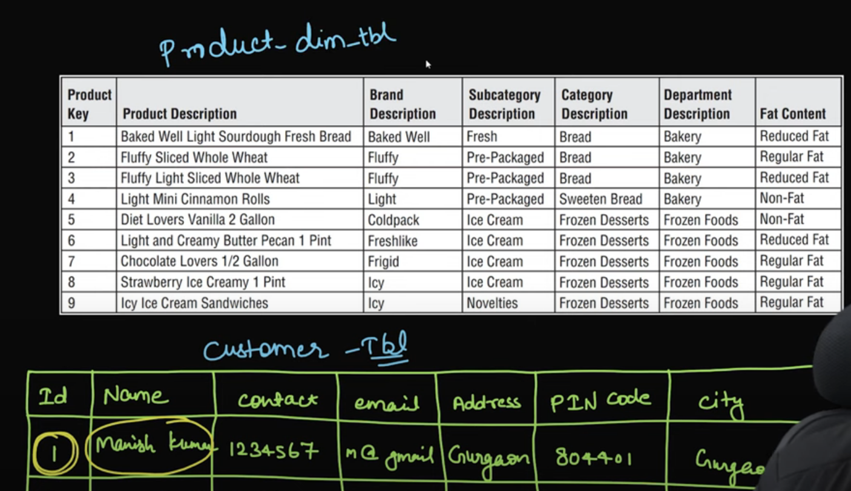

Star Schema:

From Fact Table we are just going 1 level up to get the context, such type of schema is called star schema

* 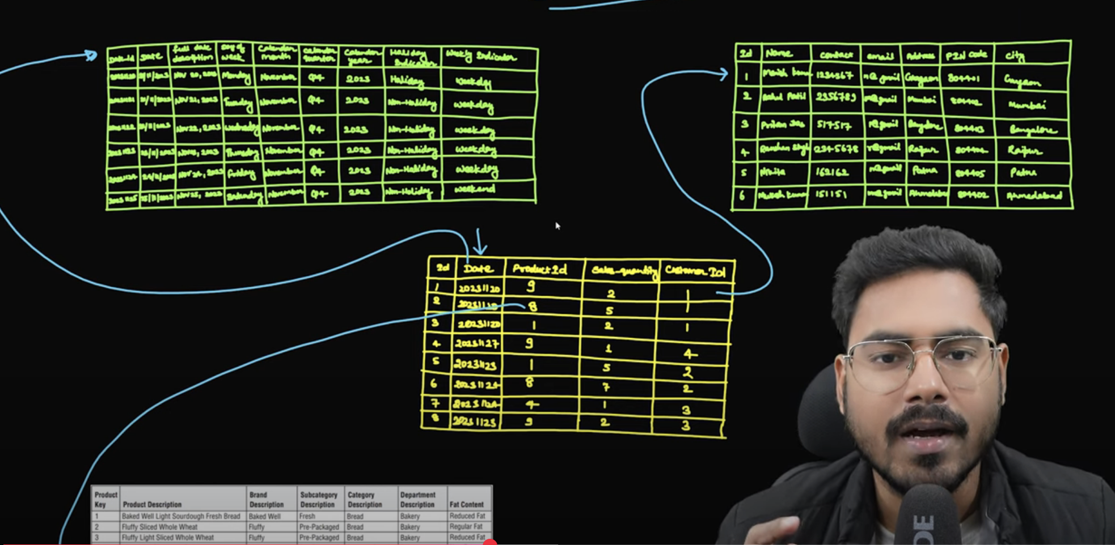
* 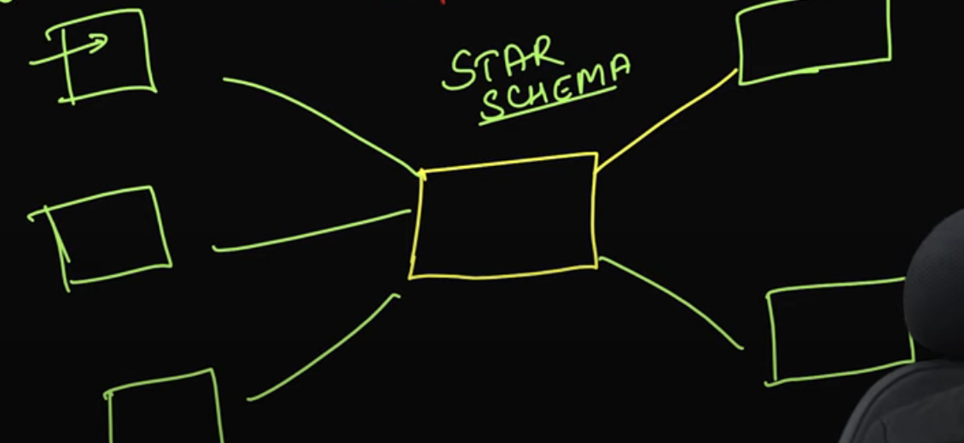
* No two dimension tables are directly linked togeather
* During Dimensional modelling importance is given to computation that storage
* 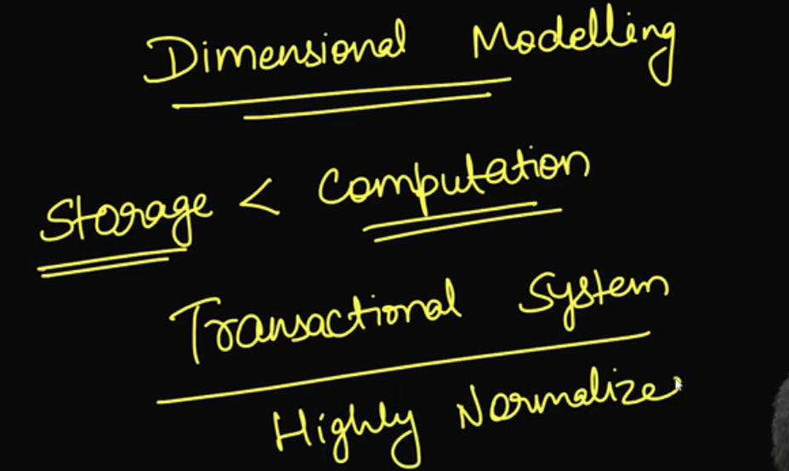

Star vs Snowflake

* 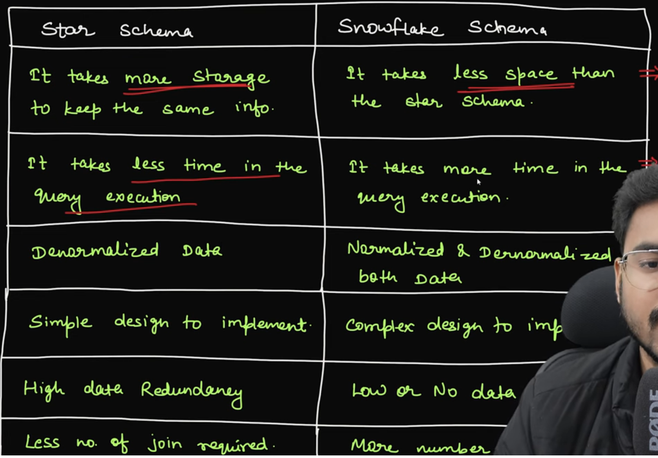
* 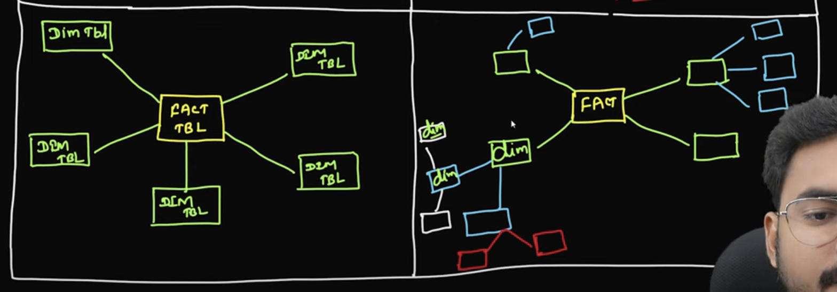
* 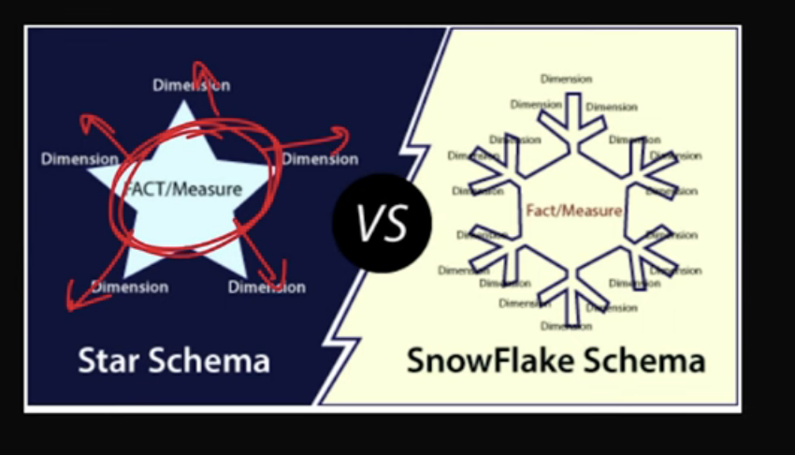
* Example for snowflak schem
* 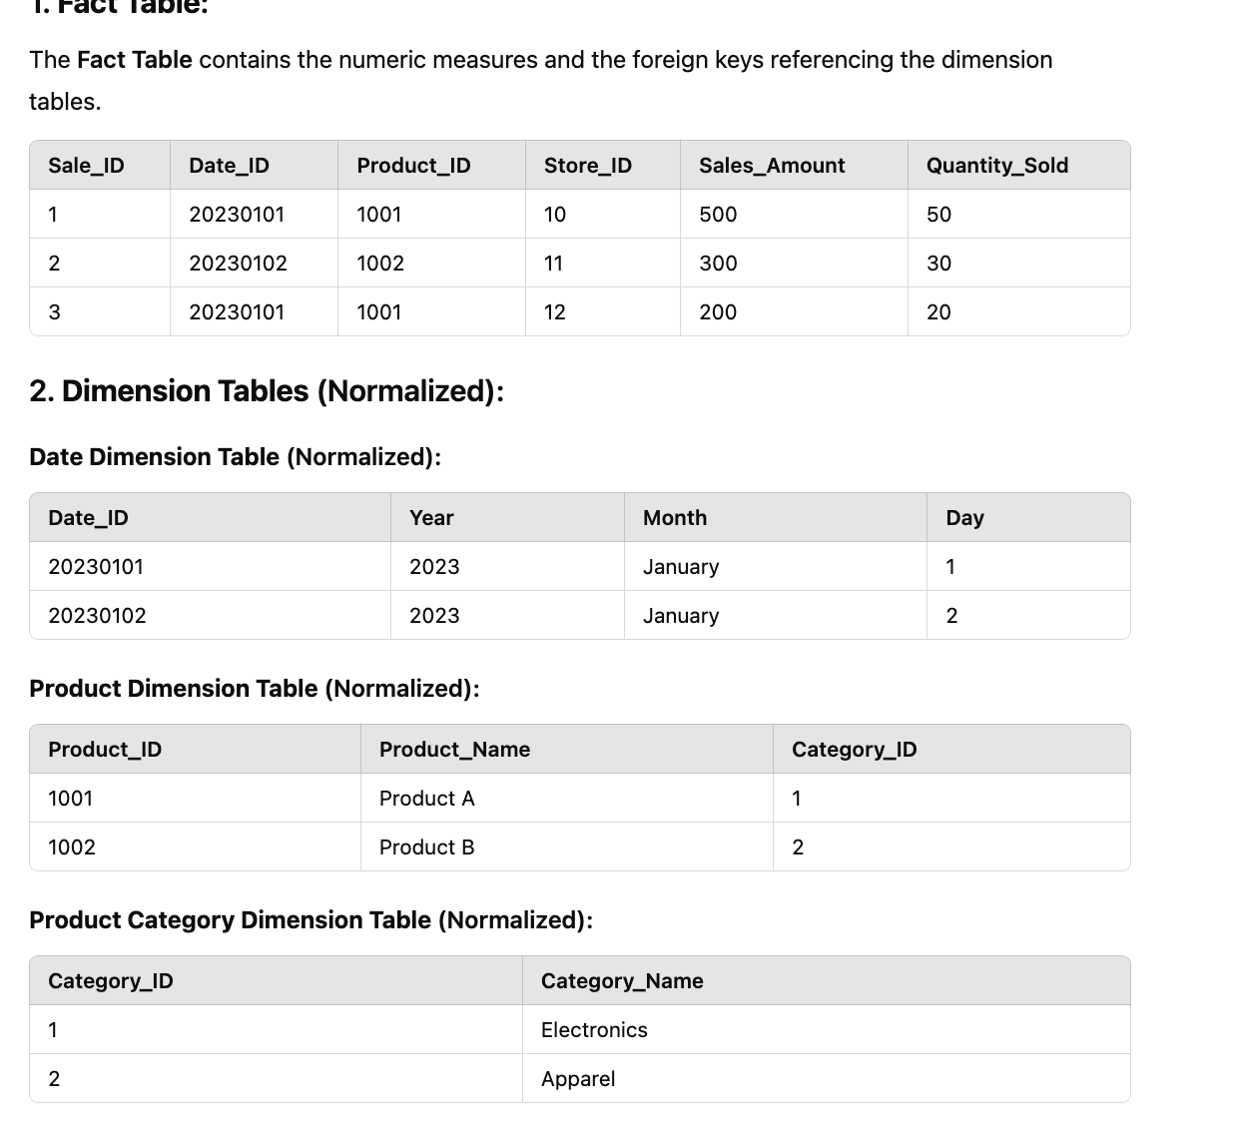

Keys in DW Tables:

* 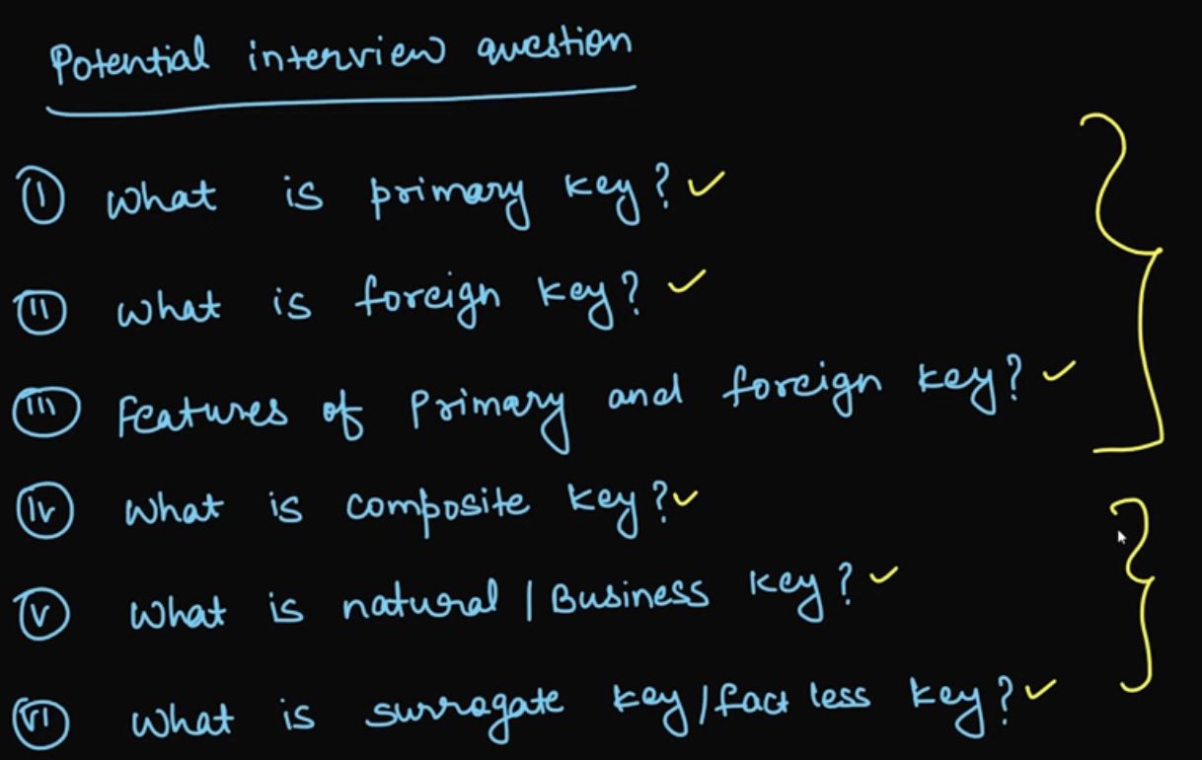

PK: Identifies each record uniquely

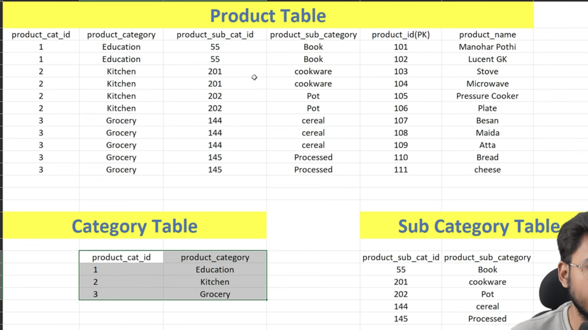

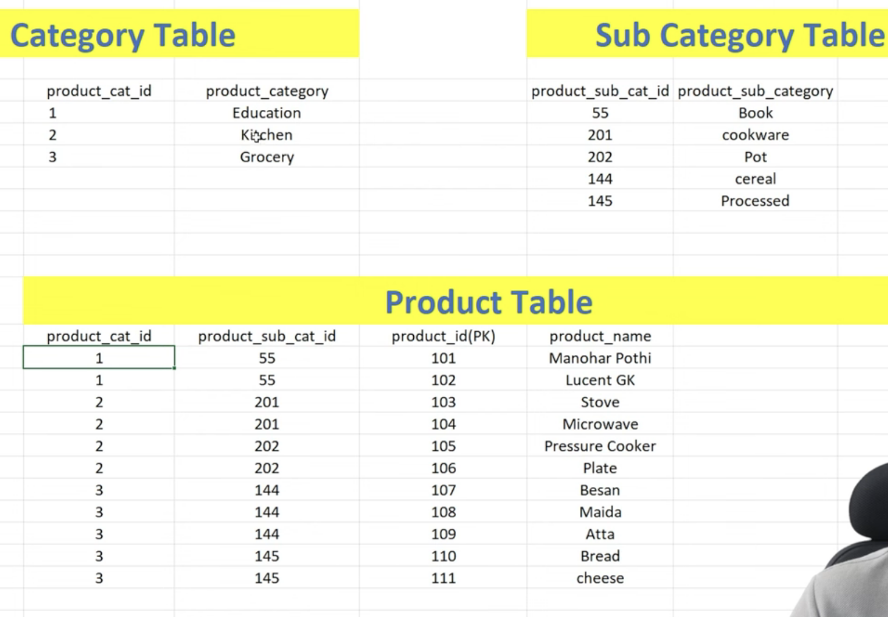

Composite Key: we consider more than one column to identify each record uniquely  
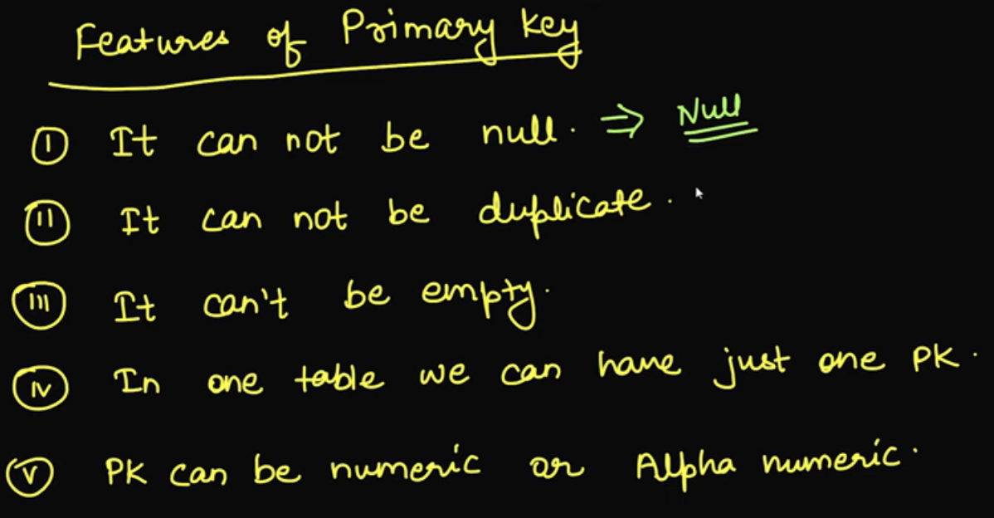

* 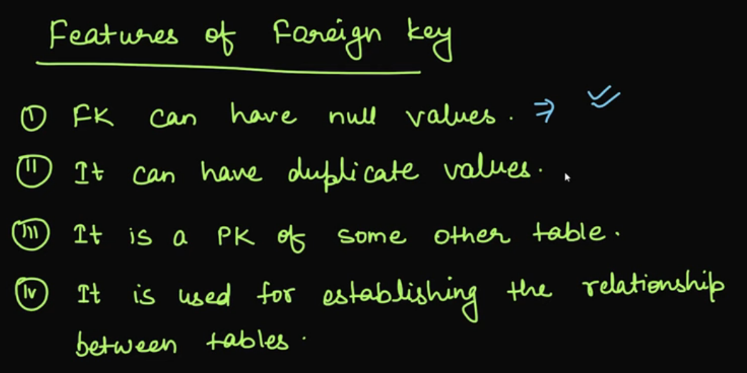

Natural Key

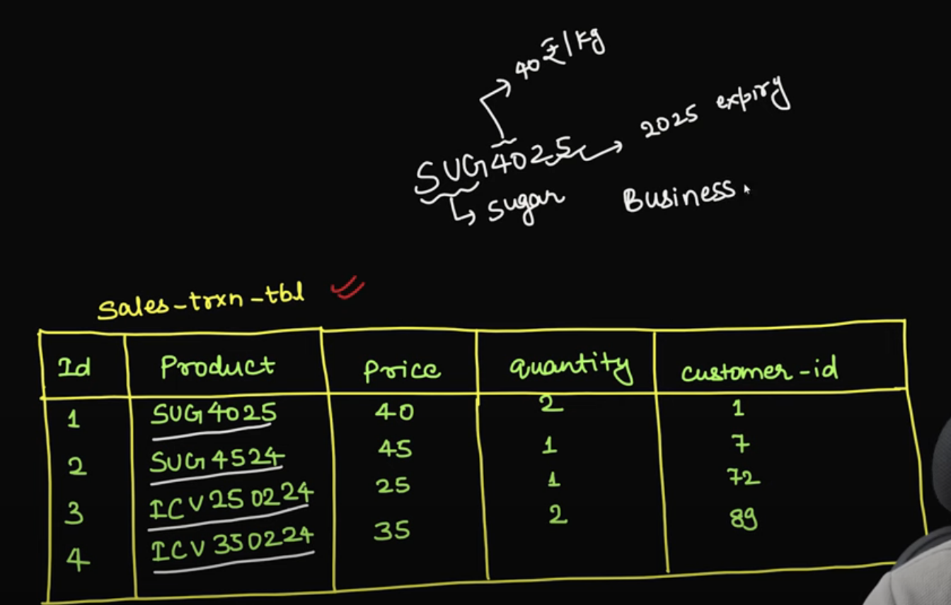

From product column we can derive business

A **natural key** in a database is a type of primary key that is made up of one or more attributes (columns) that exist in the real world and have meaning information.

Natural can be unique or might not be as well

* 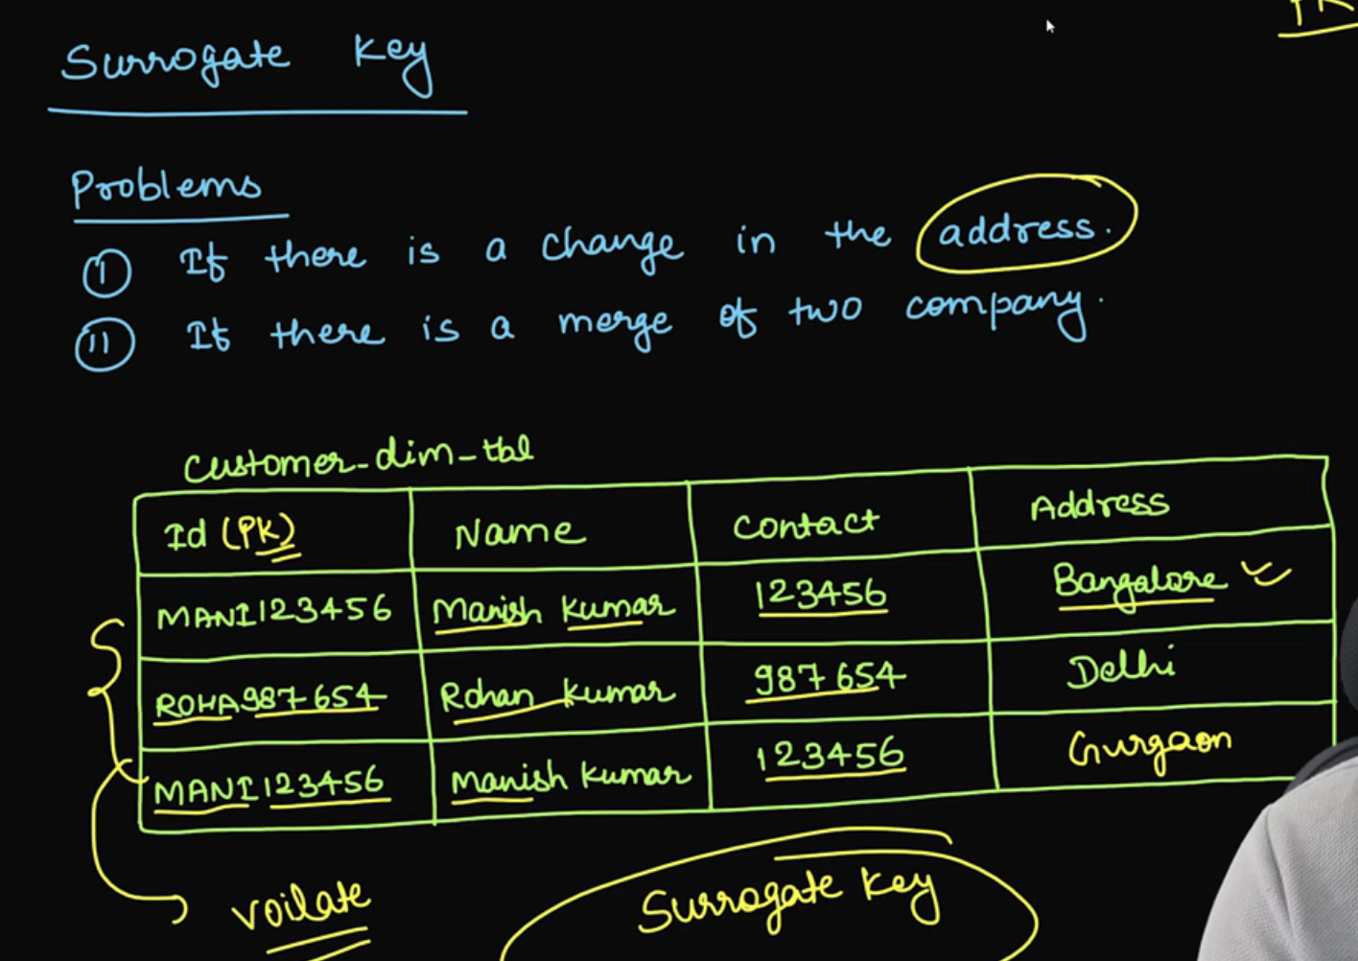

Surrogate Key:

* 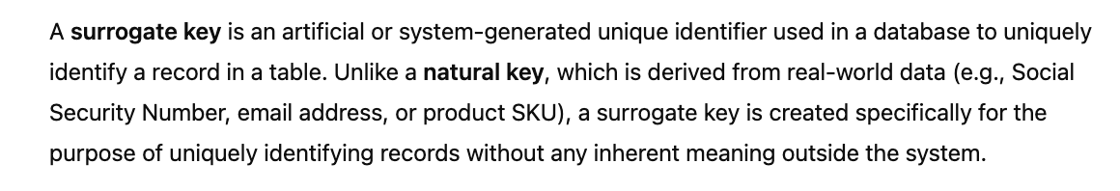
* 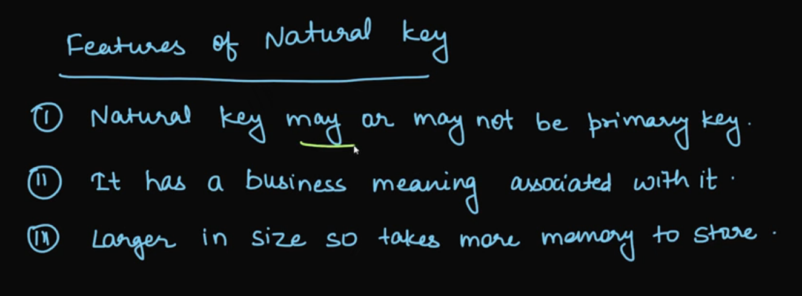
* 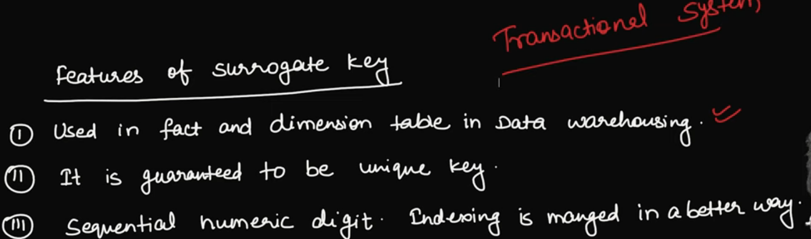

SCD (Slowly Changing Dimension):

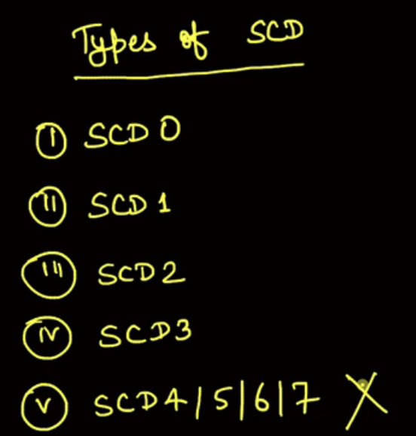

SCD – 0 -> Columns never Change like DOB, DOJ

SCD -1 :

This type overwrites the old value with the new one, without tracking historical data.

Suppose my initial address is Gurgaon and then It is changed to Bangalore, here we have updated original row

* 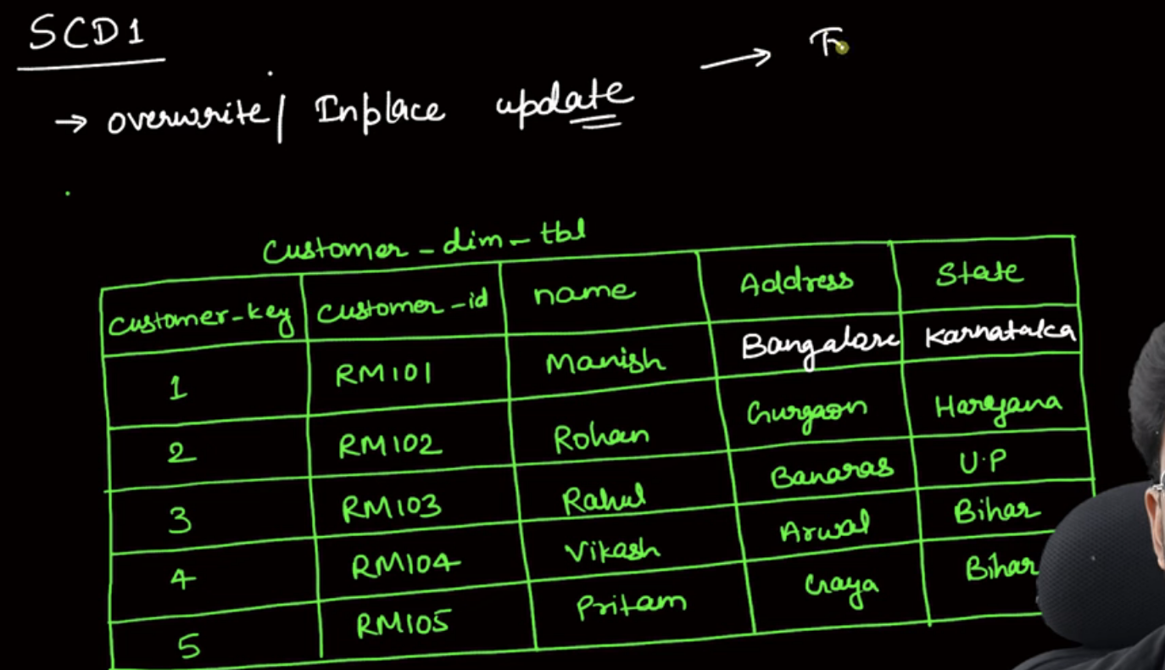

Disadvantage with this approach, we loose track of historical reference

Another issue is reporting done previously will be affected

SCD – 2:

* 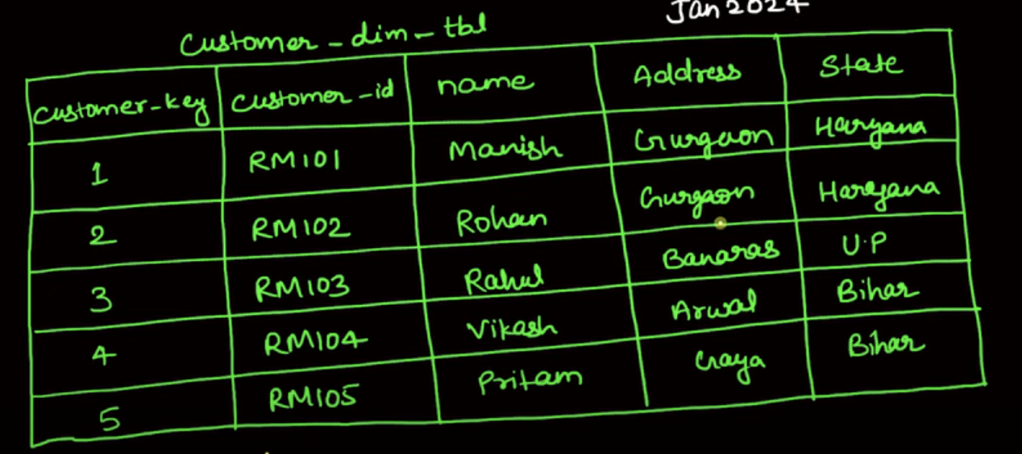
* 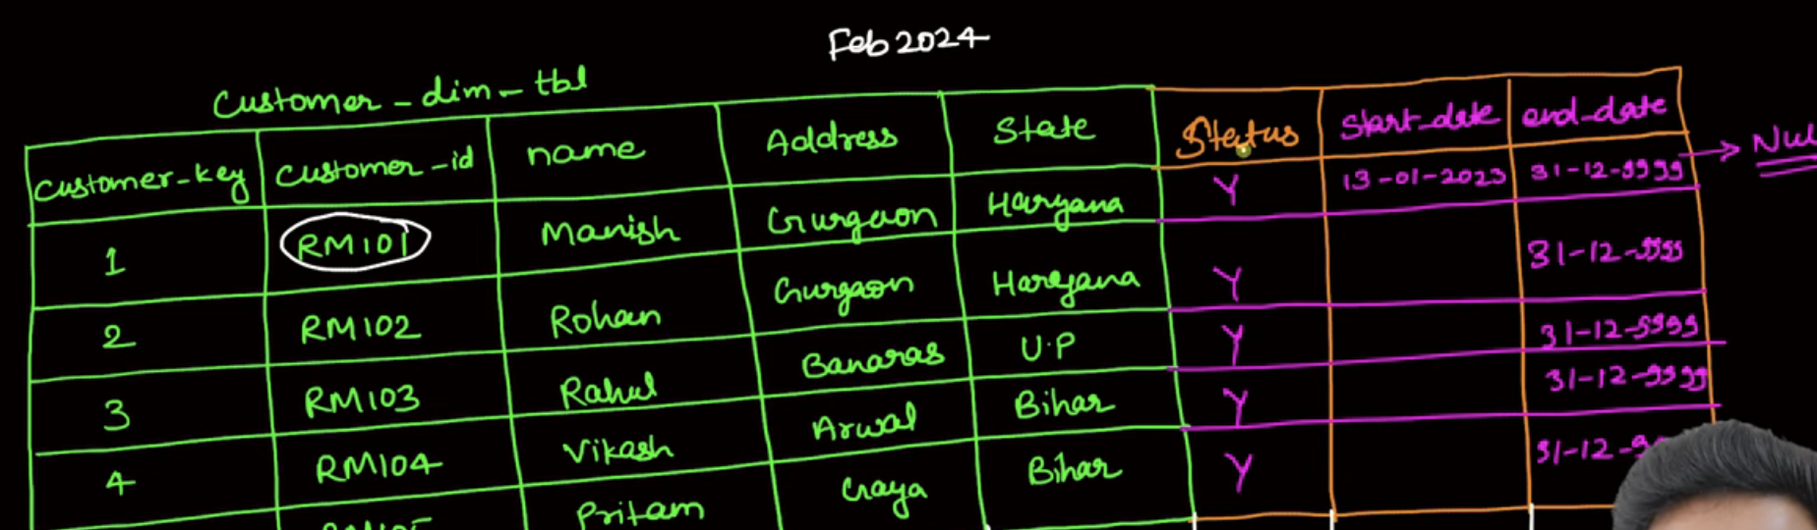
* 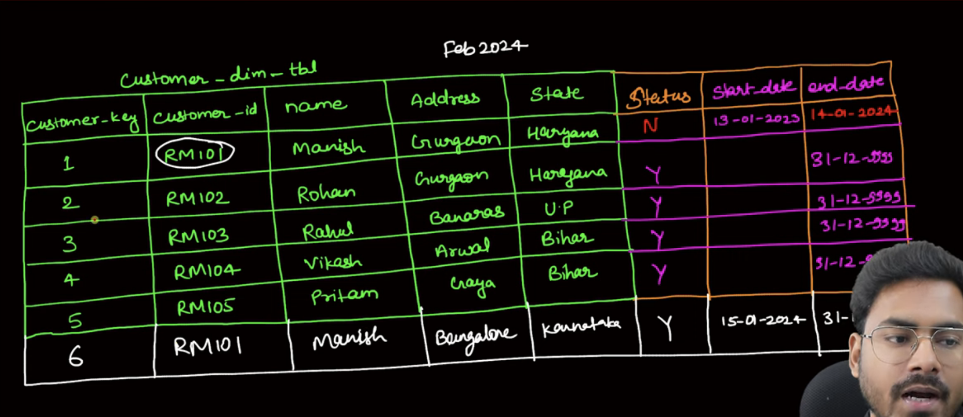

SCD-3:

the table holds both the current and previous values for an attribute. This is useful when you want to keep limited historical data, typically just the current and one previous value.

* 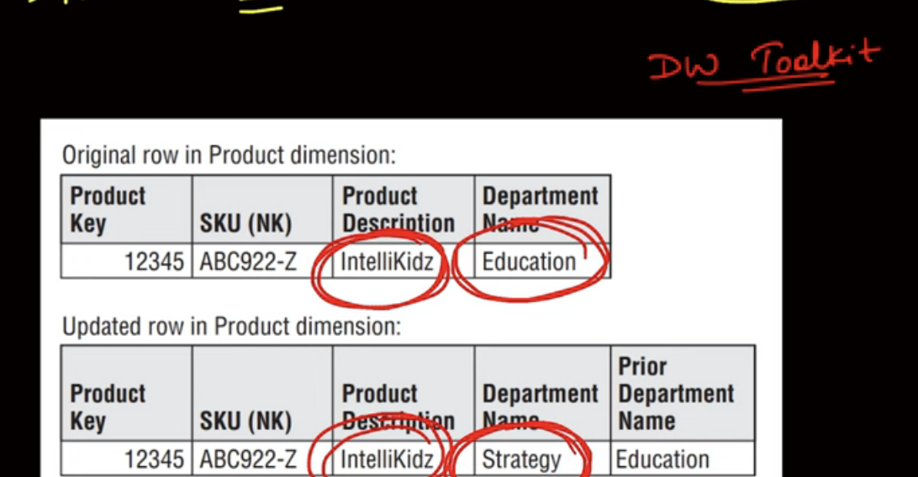
* 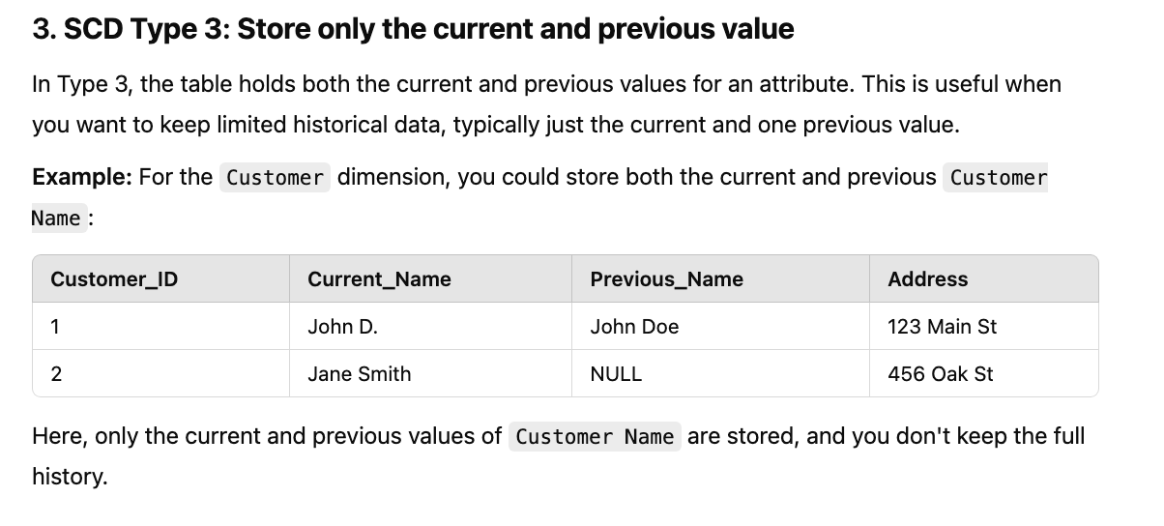

If I want to compare with previous one then I use SCD-3

SCD 4 & 5:

* 
 